Burton 4-H T-Shirt Order Form

Black Glow Turtle White W/Pocket Blue Island Tie-Dye
Sizes: YM-XXL (short sleeve only) Sizes: S-XXL (short sleeve only) Sizes: YM-XXL (short sleeve only)
Material: Dry fit & cotton Material: Cotton only Material: Cotton only
Price: $15.00 dry-fit / $15.00 cotton Price: $15.00 Price: $15.00
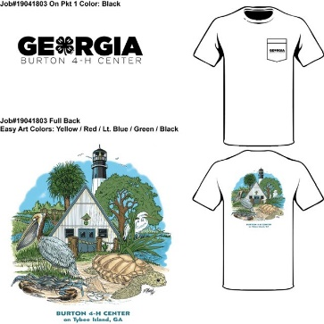
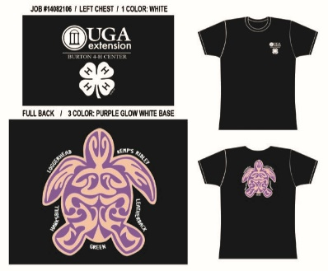
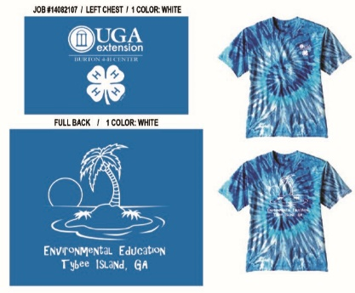

Pink & Green Manatee Navy Turtle X-ing Blue Bird EE Quote
Sizes: S-XXL (short sleeve only) Sizes: S-XXL (short sleeve only) Sizes: S-XXL (long sleeve only)
Material: Dry-fit & cotton Material: Dry-fit Material: Dry-fit & cotton
Price: SALE $10.00 dry-fit / $15.00 cotton Price: SALE $10.00 dry fit Price: $20.00 dry-fit / $20.00 cotton
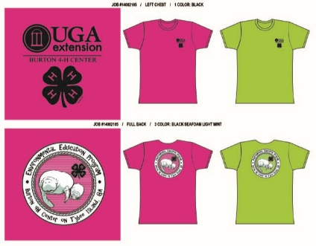
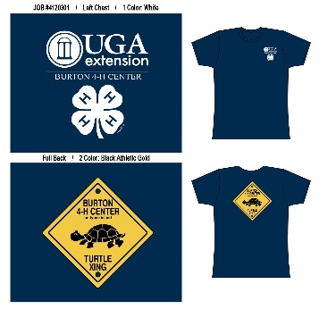
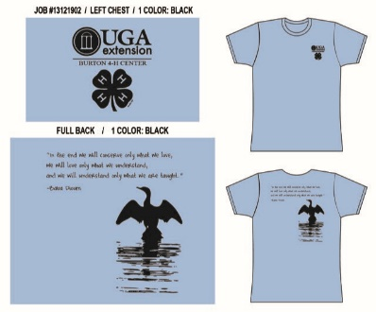

Lead Teacher Name: ___________________________________________ Cell #: ___________________________________
School: ______________________________________________________ Dates of Trip: ____________________________
Address: ___________________________ City: _____________________ State: ____________ Zip Code: ______________
STYLE & MATERIAL  *Please mark (X) dry-fit or cotton | Youth Medium | Adult  Small | Adult Medium | Adult  Large | Adult  X Large | Adult  XX Large | TOTAL # SHIRTS
Black Glow Turtle
___ Dry-fit ____ Cotton
White w/Pocket  ____ Cotton only | N/A
Blue Island Tie-dye
____ Cotton only
Green Manatee  ____ Dry-fit ____ Cotton | N/A
Pink Manatee  ____Dry-fit ____ Cotton | N/A
Navy Turtle X-ing  ____ Dry-fit | N/A
Blue Bird EE Quote  ____Dry-fit ____Cotton | N/A

PAYMENT: Please have a separate check for t-shirt orders made payable to: Georgia 4-H Club Foundation.

HOW TO ORDER: Email or fax your order AT LEAST 5 WEEKS in advance of your scheduled trip. Please pick-up your order from the canteen during your field study. Please note that shirt styles may vary in material and size options available.

