T-Shirt Group Order Form

HOW TO PAY:
Burton 4-H Center requires one separate check for group t-shirt orders. We will create and email a final t-shirt invoice from this submitted form. Please make group order payment to: Georgia 4-H Club Foundation.

HOW TO ORDER:
To ensure availability for your group, submit your order a minimum of five weeks in advance of your scheduled trip. Please pick-up your group order from the canteen during your field study. Please note, all individual orders are to be purchased during scheduled “canteen time” during your trip.

AVAILBILITLY OF SIZES & DESIGNS:
We carry a variety of shirts in our Canteen (Gift Shop). Pictured on page 2 are our current available designs noted with shirt material (dry-fit or cotton). All shirt sizes range from Adult Small to Adult 2XL. Please note that styles and sizes vary on current stock and on-sale shirt designs are not guaranteed.

GROUP INFO:
School: __________________________ Dates of Trip: ________________
Lead Teacher Name: __________ Cell #: ____________ Email: ____________
Bookkeeper Name: ___________ Phone #: __________ Email: _____________
School Address: ______________ City: _________ State: _____ Zip Code: _____

T-SHIRT SELECTION:
Design: |  | Price per shirt: |  | Total # shirts:

HOW MANY:
SMALL | MEDIUM | LARGE | X-LARGE | 2X-LARGE | 3X-LARGE

please complete all information on this form and send to:
Erine-Fay McNaught erinefay.mcnaught@uga.edu
9 Lewis Avenue, Tybee Island, Georgia 31328
T-Shirt Group Order Options
*Please note that materials, styles and sizes vary on current stock.

#1 – black sea turtle #2 - blue island tie-dye #3 - white burton a-frame
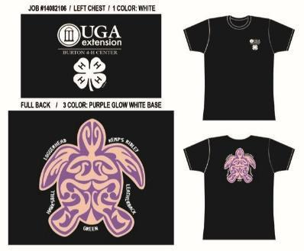
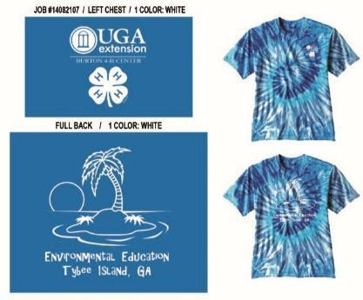
$15.00 –dry fit only $15.00 –cotton only $15.00 – cotton only

#4 – rainbow tie-dye #5 – bird nature quote #6 - pink or green manatee
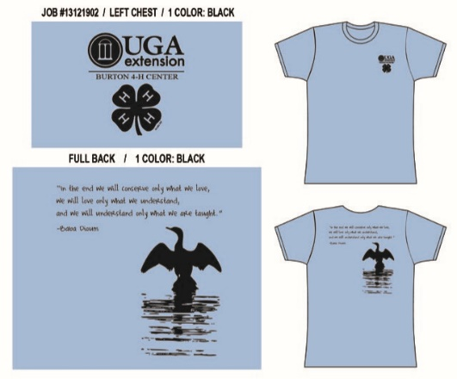
$15.00 – cotton only $7.50 - limited cotton / dry fit $7.50 – limited cotton / dry-fit

#7 - navy turtle x-ing
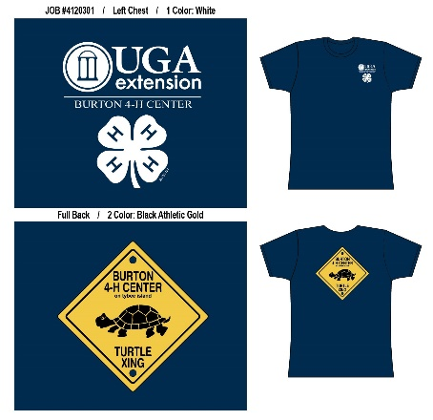
$7.50 – dry-fit only

