Social Emotional Camp Refection Guide
Adapted by: Laura Goss, Georgia 4-H Military Liaison
Contact: laurwalt@uga.edu

Reference

Walker, K., Olson, B., & Herman, M. (2019). Social and Emotional Learning in Practice: A Toolkit of Practical Strategies and Resources (2nd ed.). St. Paul, MN: University of Minnesota Extension.
Activities
Human Bingo
Reference Pages: 51- 52 in the University of Minnesota Extension, SEL in Practice a Toolkit of Practical Strategies and Resources
Supplies: Bingo Cards (p.52) 1 per Child, Markers/pencils, Instruction sheets
Time: 10- 15 minutes, depending on group size
Note: Great introduction activity to emotions and personal attributes.

Two Truths and a Wish
Reference Pages: 53 in the University of Minnesota Extension, SEL in Practice a Toolkit of Practical Strategies and Resources
Supplies: Optional Example SEL statements from Human Bingo (p.52) in the University of Minnesota Extension, SEL in Practice a Toolkit of Practical Strategies and Resources
Time: 10-15 minutes
Note: The students do not need to write anything down, but can if they choose to do so.

Activities
Meet the Wobbies
Reference Pages: 66, 68, 71, and 72 in the University of Minnesota Extension, SEL in Practice a Toolkit of Practical Strategies and Resources
Supplies: 2 Sets of Wobbie Stories per cabin
Time: 30 Minutes
Note: 4 Stories are provided. Discuss one story at a time. Depending on discussion you might discuss all or just one. Small military aspects were added into the story, but can be edited out for general 4-H audiences.
The Power of Empathy
Reference Pages: 110 and 111 in the University of Minnesota Extension, SEL in Practice a Toolkit of Practical Strategies and Resources
Supplies: Phone (at cabin location) or for classroom style reflection at camp set up includes a computer, projector, and speakers.
Time: 30 Minutes
Note: Might be ideal to have youth circle up for this activity. A sense of trust should be established before completing this activity. Not ideal as your first SEL reflection.
Emoji Reflection
Reference Pages: 57- 60 in the University of Minnesota Extension, SEL in Practice a Toolkit of Practical Strategies and Resources
Supplies: Emoji Cards 1 per Child, Markers/pencils
Time: 15 - 30 minutes
Note: A basic understanding of what an emoji is will support youth participation in this activity. Depending on you group age and dynamics this activity will lead to sharing about camp and emotions.

Human Bingo

Incorporate SEL concepts into your daily program routines and put an SEL-spin on your everyday icebreaker activities. The goal of this Human Bingo game is to discover the group members’ different SEL strengths and preferences.
Why This Matters
- This activity facilitates self-awareness and reflection as youth think and share about themselves and their strengths.
- Youth will practice active listening and understanding each other.

Getting Started
- Materials: Provide printed Bingo sheets and pens.
- Total time: 10 - 15 minutes, depending on group size.
- This works well with a large group, 20-30 people is best.

How to Do It
- Give each participant a Human Bingo Card. For each item, youth will find a person in the group for whom that statement is true and ask them to initial the box. Consider having youth share an example rather than just signing off. Continue until a student completed a row either horizontally or vertically.
- Tell everyone to begin! The person who fills out a row first shouts “Bingo!” and the game ends.
- Debrief: “What was difficult about this activity? What was easy? Any surprises?”
Take It Further
- Play Two Truths and a Wish to extend this activity or use this activity to support Two Truths and a Wish during your next session.

Human Bingo

I am a good listener | I can tell when others are angry | I get along well with others | I easily share my feelings with others | Others can depend on me
I can easily describe my feelings | I like helping people | I am not easily distracted | I am able to show affection | I manage my time well
I don’t give up | I prefer to work  independently | I know myself well | I can tell when others are annoyed | I know how to calm myself down
I make friends easily | I am a good problem-solver | I can accept criticism | I prefer working in groups | I  am patient
I can break goals into steps | If I say I’ll do it, I’ll do it | I can motivate others | My friends  can trust  me | I am a hard worker

Two Truths and a Wish

Incorporate SEL concepts into your daily program routines and put an SEL-spin on your everyday icebreaker activities. The goal of Two Truths and a Wish is for participants to get to know each other.
Why This Matters
- This activity facilitates self-awareness and reflection as youth think and share about themselves.
- Youth will practice active listening and understanding each other’s strengths.
- Honesty is an important part of effective communication and relationships.

Getting Started
- Optional materials: Provide participants of social emotional statements from the Human Bingo sheets.
- Time: 10-15 minutes.

How to Do It
- In this classic get-to-know-you icebreaker, players tell two truths and one wish. The object of the game is to determine which statement is the false one or the wish. Putting an SEL spin on this game, ask players to consider truths and lies related to their social and emotional skills.
- An SEL Wish, something that is not true — yet something that the person wishes to be true. For example, someone that is not good at time management might say: “I am never late." This interesting spin on the icebreaker can often lead to unexpected, fascinating results, as people often share touching wishes about themselves.
- Ask everyone to arrange themselves in a circle. Begin by asking, can you tell when someone is lying? How? Do you think you can hide when you are lying? Today we are going to share three SEL statements about ourselves. Two must be true statements, and one must be false.
- Example SEL statements: I am patient, I make friends easily, I prefer to work independently, I don’t mind when a permanent change of station (PCS) occurs, I am determined, I can read others’ moods, I like taking on extra roles, helping my family during a deployment is important to me, I know how to calm myself down. Share or provide the Human Bingo sheets to youth as ideas for SEL statements.
- Each person then shares the three statements (in any order) with the group. The goal is to determine which statement is false. The group votes on which one they feel is a lie, and at the end of each round, the person reveals which one was the lie/wish.
- Debrief: What did you do to try to convince the group that your lie was true? How were you able to figure out if someone was lying? Why is honestly important in positive relationships? How do you feel when people lie to you? How would having your WISH become a reality help you personally?
Take It Further
- Encourage youth to reflect personally on ways they can make their WISH a reality. How can they support themselves in achieving the skills they desire? Remind the youth that you and the other adults at camp are here if they need support.

Meet the Wobbies
Wobbies are case narratives of individual youth who are navigating through one or more parts of the Ways of Being (WOB) model. The stories of these characters can be used to spark conversation among youth about the social and emotional skills at play in the stories and in their own SEL development. The Wobbies were created in partnership with a team of diverse young people as part of the Youth Voice Project on Youth Ways of Being.
Why This Matters
- The Wobbie stories provide a way for youth to begin to think and talk about the social and emotional skills of other youth as well as themselves.
- Discussing the life experiences of other people allows youth to practice social and emotional skills such as empathy, problem-solving, and understanding others’ feelings.
Getting Started
- Materials: Copies of 2-4 Wobbie stories per cabin depending on cabin size.
- Time: Devote at least 10-15 minutes to each Wobbie.
- If discussions are going well do not cut off discussions; however, if the discussion has stalled move on to the next story.
- 4 stories have been provided. You do not need to do all 4 but choose which one applies best to your group or allow youth to choose.

How To Do It
- Explain to the group of youth that you will be reading stories about other youth and then discussing their experiences.
- Read the story individually or read aloud as a group.
- After reading a story, use the discussion questions below each story to spark a conversation. Encourage youth to share personal experiences.

Take It Further
- Discuss personal stories (if any) that relate to the story they just heard. How could the teen have improved the emotional reaction or have the teens share ways the individual handled themselves appropriately.
- After reading the Wobbie stories, discuss with youth which Wobbie they most related to and why.
- Consider having youth create a Wobbie of themselves at this point in their lives. Have youth think about which of their personal traits related to their social skills (connecting with others, empathy sharing), emotional skills (handling stress well, patience with others, not giving up when challenged) are strongest and which could be improved.
- Youth could write a story about the Wobbie of their choosing based on the characteristics they desire for themselves, choose to draw a picture of themselves, and/or list ways they will achieve their ideal self.
Meet the Wobbies

NIKKI
Nikki used to be one of those students. You know the kind: the ones who get good grades, participate in clubs and volunteer activities, and tutor younger kids after school. In middle school, Nikki was the captain of the dance team, helped organize trips for the environmental awareness club and got A’s in her classes. She looked forward to high school, where they did real experiments in real science labs, where she could publish stories in the school magazine, and where the dance team would perform during halftime at games. But freshman year was tough not only was she was in high school, but her family moved to South Georgia where she knows no one. In her new school she struggled in geometry class, but she was embarrassed to ask for help because she used to be one of the “smart” kids. The school magazine rejected the first story she submitted for the fall issue. Every time she got up to do a presentation in any class, she would freeze and forget everything she’d planned to say. Nikki’s grades started falling. By the end of the year, she had dropped out of dance team, had given up on the literary magazine and was failing math. She knew she needed to get some help with schoolwork but wasn’t sure how to. She was so far behind anyway, what was the point? School used to be so easy, but maybe she just wasn’t good at it anymore, so why should she even try to do well at anything? Besides, she didn’t want to move. The Army made them move not her.

Discussion Questions
- What are some of the feelings that Nikki is having right now?
- Why does she feel this way?
- What advice do you have for her?
- Think about a time where you tried to do something hard. What was it? What did you do to accomplish this? How did you feel about the outcome of what you did?
- When is it important to stick with hard things? When is it okay to let those things go?
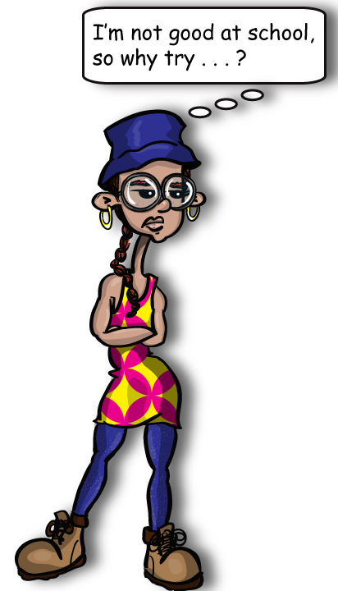
- What long-term goals do you have? What short-term goals do you have? How could you go about accomplishing these goals?
- What advice do you have to help make a PCS or a move easier?

Meet the Wobbies

CHRIS
Chris has lots of friends. People like him because they say he is friendly and positive. He’s good at cheering other people up, and at “looking on the bright side.” He gets good grades at school, and adults think he’s “mature” and “responsible.” Chris has a good reputation with his friends and with adults in the community, and he knows he should feel lucky. But sometimes, Chris’ life feels like an act. Sometimes he’s sad. Sometimes he’s mad. Sometimes he’s confused and isn’t sure what he should do in certain situations. Some of this stems from his mom being in the Reserves, but not all of it. Chris likes his friends, but sometimes he feels like he doesn’t fit in with them or they won’t understand. He doesn’t know how to tell them that’s he’s feeling bummed out or confused, because he’s Chris, the Good Guy. He feels like the only time he can really say what’s he’s feeling is when he’s in front of the mic, performing.

Discussion Questions
- If Chris was one of your friends, how would you support him?
- What advice would you give to Chris?
- Have you ever felt like Chris before? How did you handle the situation?
- How are you similar to Chris? How are you different?
- In what situations do you feel most comfortable sharing your thoughts and feelings? In what situations is it hard to express yourself?
- Which feelings are easy for you to express? Which feelings are hard for you to express? Why do you think certain feelings are easier or harder to share with others?

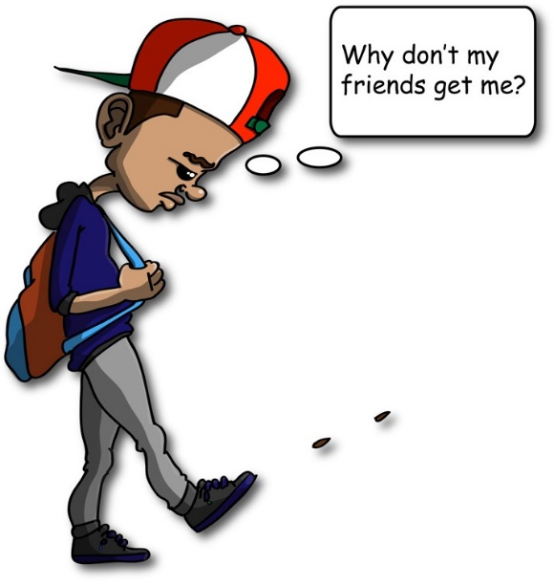

Meet the Wobbies

MAI
Mai transferred to a school on the other side of town at the beginning of the school year. Her new school has classes in graphic design and an exchange program that lets students spend a semester in Japan—two things she’s wanted to do for a long time, but that weren’t available at her old school. Her friends from her old school tease her by saying that she goes to a ‘fancy school’ now with the ‘fancy kids.’ Many of Mai’s new classmates live in really nice houses and go on vacations to places she’s only dreamed of visiting. Mai was a little worried that she wouldn’t fit in, but she’s enjoyed making new friends, and some of them just invited her to join the school’s newspaper staff. She feels good about being able to do things that she likes to do and feels like she has a lot in common with her new classmates, even though they live on opposite sides of town. Last week, she went to a basketball game where her new school played against her old school. After the game, Mai went out with some of her new friends. They talked a little about how the game went (her new school won). Then her friends started making fun of the kids at her old school. Mai felt uncomfortable, like she should stand up for her old school, but is worried that it will make them dislike her. It’s just like when her friends from her old school call her new classmates’ snobs. But she doesn’t know what to say. She loves all of her friends, and wants to get along with all of them, but she thinks what they’re saying is wrong. She doesn’t know whether she should speak up or hold her tongue.

Discussion Questions
- What are some ways Mai could handle the situation? What would you decide to do?
- Mai is deciding between “speaking her mind” and “holding her tongue”. Have you been in a similar situation before? What did you do?
- Have you ever had to change schools? What was your experience like? What strategies did you use to make new friends?
- Think about the last time you had a conflict with your friends. How did you handle it?
- How are you similar to Mai? How are you different?
- If you were in Mai’s situation, what social and emotional skills would you use to move forward?

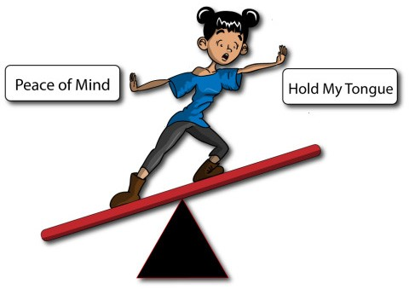
Speak My Mind
Hold My Tongue
Speak My Mind
Hold My Tongue
Meet the Wobbies

JAMES
James has to get to work on time because he wants to take Alexis to the prom. James has got prom night all planned out—a tux, a limo, dinner, flowers. Alexis is going to be so impressed. But those things aren’t cheap, so first, James has to get to work at the pizza place on time. When he got hired at the pizza place, his boss made a big deal about how they never hire teens because teens are so irresponsible, like they couldn’t trust him to do this important job of putting pepperonis on pies. It’s not like life or death. But James also knows most of his friends are having a hard time finding jobs, and it would be stupid to lose the job he already has. He’s already been late for work once, because his dad is deployed, and he had to take his sister to basketball practice before his shift to help his mom. His boss gave him this long lecture about it. James was annoyed—he’s always the best worker on his shift—but he knows that the pepperonis are just part of his plan. Pizza is his ticket to the prom.

Discussion Questions
- How are you like James? How are you different?
- What responsibilities do you juggle in your own life?
- James is motivated to work so he can go to prom. What are some of your goals that motivate you? Pick one goal. What steps are you taking to achieve it?
- How do you manage your time? What gets in the way of getting everything done?
- What strategies do you use when you have a lot to get done?
- Think of a situation in your life when you felt misunderstood by adults. How did it make you feel? How did you handle it?

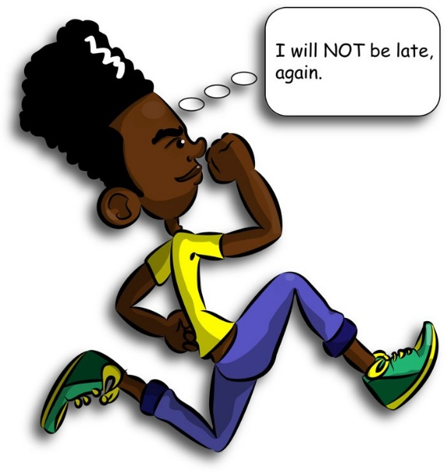

Emoji Reflection

Incorporate SEL concepts into your daily program routines and put an SEL-spin on your youth check-ins. The goal is to check in with youth and measure indiviidual and group progress. THis can be used during a strucutred time or periodicly during camp.
Why This Matters
- Consistent opportunities for self-reflection contribute to environments that support social and emotional learning because they help youth make meaning out of activities and experiences.
- SEL-focused reflection routines create space for youth to practice important social and emotional awareness skills.

Getting Started
- Optional materials: Provide emoji handouts and a writing utensil to campers or allow them to create their own emoji scale.
- Before leading the activity ensure youth understand what an emoji is.
- Time: 15 - 30 minutes

How to Do It
- Provide youth materials (emoji handout and writing utensils)
- When introducing the Emoji Reflection activity, discuss with youth what each emoji means and build a common understanding of the emoji scale for the group to use. Define the meaning of each emoji. Allow youth input in determining the meaning. The Emoji choices should correspond to a general scale. For example, all the time, most of the time, some of the time. An additional example is awesome, good, not sure, gross, lame, and no way).
- Allow youth time to silently respond to emoji reflection questions.
- Start a group discussion after the self-reflection time. Possible questions could include:
  - Do you ever have a hard time naming your emotions or noticing how you are feeling? Why do you think that is?
  - Was it hard to choose just one emotion per activity? Why or why not? How would you change the Emoji Reflection handout to better document your emotions?
  - Is it easier or harder to be honest during a self-reflection or group reflection?
- Now, create your one emoji for how you feel about the camp so far. How does being at camp make you feel? Consider if you have overcome challenges, met new friends, tried something new, or something you learned. How do you feel overall? Create an Emoji that reflects the former.
- Finally, allow campers to share or allow for personal emoji creation to be a self-reflection. You might ask the youth how they would like to handle the activity to provide youth input.

Emoji Reflection
Respond to the anchor statements by filling in the blank to reflect on and consider how you felt about that experience. Rate your feelings based on the following emoji scale. Circle the emoji that best represents how you feel.
Today I did ______________ and it made me feel…

Today I talked with ____________ and they made me feel…

Today I learned ________________ and now I feel…

At first, I thought this camp would be __________ and now I feel…

One thing I want to do tomorrow is __________, because it will make me feel…

Create an Emoji that reflects how you feel about camp so far.

The Power of Empathy

This activity allows youth ways to relate through practicing empathy with others.
Why This Matters
- Connecting with and supporting others is essential. For reserve and guard youth, they might not have youth in their communities to connect and share empathy with as it relates to their parents’ service. Camp can provide a structured time to connect and support each other.
- Sympathy minimizes someone’s pain, whereas empathy – the ability to identify with other people’s struggles and support them- is so important. Empathy connects us to their pain, helps us discover commonalities in others, and is a skill that develops by practicing giving and receiving it.

Getting Started
- Materials: video + audio for the group. You can also use a computer, projector, and speaker for use d
- Total time: 20-30 minutes
- This works best with groups that are comfortable with each other. If you do not feel your group is ready for this activity, consider a different activity like sharing their high and lows from the camp day (less personal).
- Preview the 3-minute video created by the Royal Society of Arts which is available on Vimeo or YouTube or download the MP4 (Recommended for Wahsega); https://www.thersa.org/video/shorts/2013/12/brene-brown-on-empathy. Note, this video was created for adults (talks about miscarriage briefly) not all pieces are relevant to youth, but it breaks down empathy well. Feel free to select a different video based on age of audience.

How to Do It
- Explain that the purpose of this activity is to learn about and practice empathy, an important skill for supporting friends and family.
- Discuss the concept of empathy compared to sympathy. What comes to mind when you think of the word sympathy (feeling sorry, providing comfort or assurance)? What comes to mind when you think of the word empathy (feeling with people, putting yourself in their shoes)? If you share a struggle, worry or challenge, how do you want people to respond (“that sucks, “I’ve been there”. “It could be worse”. “Why don’t you…”, “it sounds like…”, “I’m sorry”).
- Watch the 3-minute video; https://www.thersa.org/video/shorts/2013/12/brene-brown-on-empathy.
- Discussion post video using the prompts.
The Power of Empathy

How to Do It
- Discuss the four attributes of empathy that Brown (video) references:
  - To be able to see the world as others see it. This requires putting your own “stuff” aside to see the situation through someone else’s eyes.
  - To be nonjudgmental. Judgement of another person’s situation discounts the experience and is an attempt to protect ourselves from the pain of the situation.
  - To understand another person’s feelings. We have to be in touch with our own feelings in order to understand someone else’s.
  - To communicate your understanding of that person’s feelings. Rather than saying, “at least you…” or “it could be worse…” try “I’ve been there, and that really hurts,” or, “it sounds like you are in a hard place now. Tell me more about it.”
- Explain to youth that the video defines empathy as a skill that develops by practicing giving and receiving empathy. It’s a skill, and it takes practice. Have youth spend the next 10-15 minutes practicing empathy with the following activity.
- Have youth get in groups of three or in pairs. Each person in the group will take turns having each role. If you are running short on time allow youth to volunteer to be foxes first and then base the groups of that, so at least one round of practice occurs. Describe the three roles:
  - One person is the fox- someone willing to talk about a challenge they are having in their life. (Depending on the maturity of the group, consider giving scenarios. Potential scenarios might include receiving a low grade on a test, the loss of a pet, a deployment, a move, a new school, not being picked for a sports team)
  - The other person is the bear who listens and resists the urge to offer advice or try to fix it. The bear might say phrases like: “it sounds like…” “thank you for sharing.”
  - The third person is the reindeer who offers silver linings: “at least…”.
- Debrief the activity with some of these questions:
  - Foxes, what did it feel like to have someone listen to you?
  - Bears, was it challenging to not give advice? What were some of your responses to the fox? When you listened did it provide you time to consider the other persons feelings and your own experiences too that were similar?
  - Reindeer, how did it feel to offer silver linings?
  - For everyone: What is challenging about expressing empathy rather than sympathy? What do you see as the main differences between sympathy and empathy? What surprised you most about the activity? How will this activity affect your actions moving forward?

