Burton 4-H Center  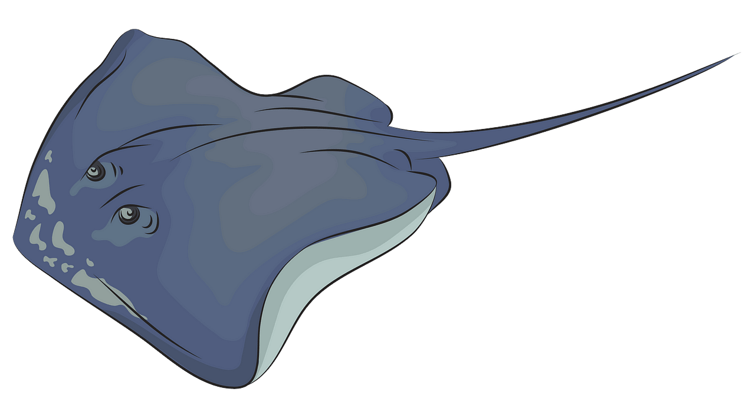  Stingrays  NAME:  DORM: | Burton 4-H Center  Stingrays  NAME:  DORM:
Burton 4-H Center  Stingrays  NAME:  DORM: | Burton 4-H Center  Stingrays  NAME:  DORM:
Burton 4-H Center  Stingrays  NAME:  DORM: | Burton 4-H Center  Stingrays  NAME:  DORM:

