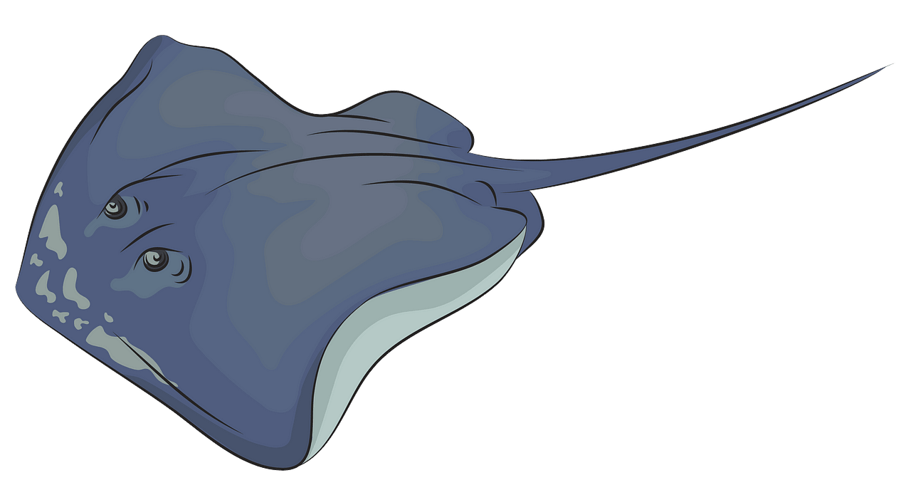  STINGRAYS  NAME:  DORM: | STINGRAYS  NAME:  DORM:
STINGRAYS  NAME:  DORM: | STINGRAYS  NAME:  DORM:
STINGRAYS  NAME:  DORM: | STINGRAYS  NAME:  DORM:
STINGRAYS  NAME:  DORM: | STINGRAYS  NAME:  DORM:
STINGRAYS  NAME:  DORM: | STINGRAYS  NAME:  DORM:
STINGRAYS  NAME:  DORM: | STINGRAYS  NAME:  DORM:
STINGRAYS  NAME:  DORM: | STINGRAYS  NAME:  DORM:
STINGRAYS  NAME:  DORM: | STINGRAYS  NAME:  DORM:
STINGRAYS  NAME:  DORM: | STINGRAYS  NAME:  DORM:

