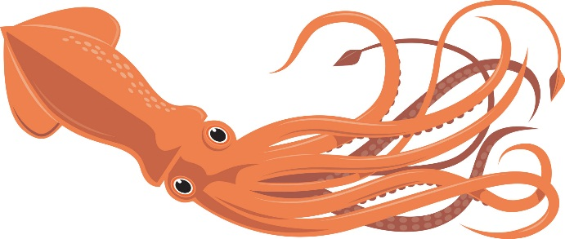  Burton 4-H Center  Squids  NAME:  DORM: | Burton 4-H Center  Squids  NAME:  DORM:
Burton 4-H Center  Squids  NAME:  DORM: | Burton 4-H Center  Squids  NAME:  DORM:
Burton 4-H Center  Squids  NAME:  DORM: | Burton 4-H Center  Squids  NAME:  DORM:

