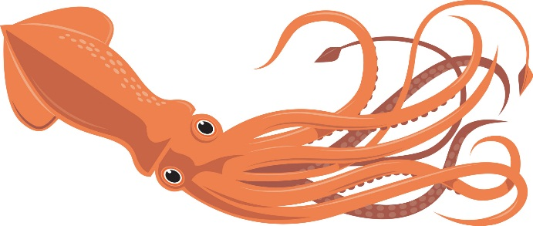  SQUIDS  NAME:  DORM: | SQUIDS  NAME:  DORM:
SQUIDS  NAME:  DORM: | SQUIDS  NAME:  DORM:
SQUIDS  NAME:  DORM: | SQUIDS  NAME:  DORM:
SQUIDS  NAME:  DORM: | SQUIDS  NAME:  DORM:
SQUIDS  NAME:  DORM: | SQUIDS  NAME:  DORM:
SQUIDS  NAME:  DORM: | SQUIDS  NAME:  DORM:
SQUIDS  NAME:  DORM: | SQUIDS  NAME:  DORM:
SQUIDS  NAME:  DORM: | SQUIDS  NAME:  DORM:
SQUIDS  NAME:  DORM: | SQUIDS  NAME:  DORM:

