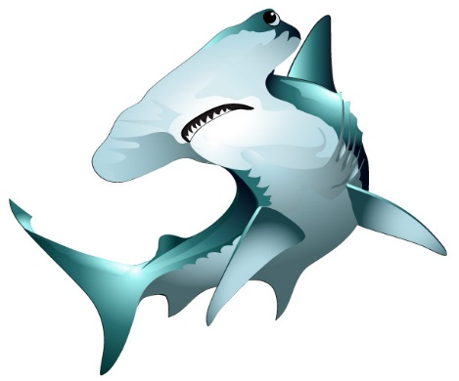  Burton 4-H Center  Sharks  NAME:  DORM: | Burton 4-H Center  Sharks  NAME:  DORM:
Burton 4-H Center  Sharks  NAME:  DORM: | Burton 4-H Center  Sharks  NAME:  DORM:
Burton 4-H Center  Sharks  NAME:  DORM: | Burton 4-H Center  Sharks  NAME:  DORM:

