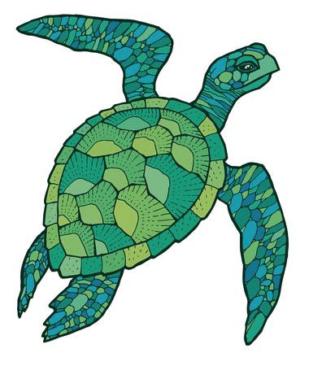  SEA TURTLES  NAME:  DORM: | SEA TURTLES  NAME:  DORM:  DORM:
SEA TURTLES  NAME:  DORM: | SEA TURTLES  NAME:  DORM:
SEA TURTLES  NAME:  DORM: | SEA TURTLES  NAME:  DORM:
SEA TURTLES  NAME:  DORM: | SEA TURTLES  NAME:  DORM:  DORM:
SEA TURTLES  NAME:  DORM: | SEA TURTLES  NAME:  DORM:
SEA TURTLES  NAME:  DORM: | SEA TURTLES  NAME:  DORM:
SEA TURTLES  NAME:  DORM: | SEA TURTLES  NAME:  DORM:  DORM:
SEA TURTLES  NAME:  DORM: | SEA TURTLES  NAME:  DORM:
SEA TURTLES  NAME:  DORM: | SEA TURTLES  NAME:  DORM:

