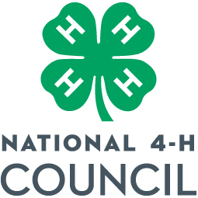
MEDIA AND INFORMATION RELEASE

Return release to: Denise Phelps National 4-H Council
7100 Connecticut Ave
Chevy Chase, MD 20815
Phone 301-961-2819
Email: dphelps@fourhcouncil.edu

I give to the National 4-H Council, its nominees, agents, and assigns, unlimited permissions to copyright and use, publish, and republish for purposes of advertising, public relations, trade, or any other lawful use, information about me and reproductions of my likeness (photographic or otherwise), my voice, and any related written text, whether or not related to any affiliation with National 4-H Council, with or without my name. I hereby waive any right that I (and Minor) may have to inspect or approve the copy and/or finished product or products that may be used in connection therewith or the use to which it may be applied.

Name of person photographed, recorded, or interviewed (PLEASE PRINT) Age (if minor)

_____________________________________________________________________________
Street address, city, state, and zip code

_____________________________________________________________________________

_____________________________________________________________________________
Signature Date

Consent of parent or legal guardian if above individual is a minor.
I consent and agree, individually and, as parent or legal guardian of the minor named above, to the foregoing terms and provisions. I hereby warrant that I am of full age and have every right to contract for the minor in the above regard. I state further that I have read the above information release and that I am fully familiar with the contents.

Signature Relationship

Producer, writer, or photographer

Assignment/Date
Location

