Military Installation GA 4-H Club Guide

This Georgia 4-H resource goal is to provide military Child and Youth Program (CYP) professionals with the tools to successfully carry out a 4-H club meeting on installations.

Table of Contents
General 4-H Club Meeting Agenda Template 2
Club Meeting Agenda Example 3
Military Pre-Club Meeting Welcome Letter Template 4
4-H and American Pledge (Printable) 5
4-H Club Attendance Roster Template 6
Additional Resources 7

General 4-H Club Meeting Agenda Template

Pre-Meeting Activities: Plan something for early arrivals to do.
Welcome & Opening: This is a routine portion of the meeting that should be completed at all meetings.
- Welcome everyone and direct them to the sign-in sheet.
- Once everyone is there, recite the American Pledge and 4-H Pledge to open the meeting (find on page 5).
- Before starting the lesson, you could do an icebreaker activity if you have a new group to get everyone more acquainted. Alternatively, choose a brief recreational game to help youth get energized for the club meeting.
- Once the role is taken/everyone is signed in, start with any business.
BUSINESS: Briefly review any news and upcoming events and review what was done at the last meeting
- Introduce the members to the activities planned for the day.
ACTIVITY: Present your lesson or activity to your members
- Involve members in the lesson when possible.
- Use the Experiential Learning Model (interactive activities: Do-Reflect-Apply) as a guide for various activities and experiences.
- Have one or two youth demonstrate how to do something, then have other members try (for some items, an adult or a youth/adult team may need to demonstrate).
DEBRIEF: Guide the members through a debrief activity that allows them to discuss any questions or reflect on what they learned.
NEXT MEETING: Discuss what is planned for the next meeting and any materials needed.
- Remind everyone of the date, time, and location for the next meeting and any special 4-H events or activities that are on the calendar. This is a great time to share a newsletter or flyer from your local 4-H clubs or on-base events.

KEY POINTS TO REMEMBER

Involve youth in the planning.

Plan each part of the meeting, but also plan for flexibility.

Plan backup activities (rain plans for outdoor activities, etc.).

Assemble all the materials needed ahead of time.

Go through the activities prior to the meeting to anticipate problems, determine “helpful hints”, and learn how to best guide youth rather than do for them.

Adapted from materials developed by Colorado State University Cooperative Extension by Georgia 4-H AmeriCorps VISTA, McKenzie Tankersley in 2023

Club Meeting Agenda Example
LESSON CITATION:
https://extension.unh.edu/sites/default/files/migrated_unmanaged_files/Resource006627_Rep9497.pdf. (n.d.). 4th H for Health Curriculum Leader Guide.
PRE-MEETING ACTIVITIES:
- Youth Sign-In: Provide the check-in sheet or electronic survey link.
- Activity to get thinking: Present students with different drinks; soda (i.e. Coke), sports drink (i.e. Gatorade), juice (i.e. Capri Sun), water, and an energy drink (i.e. Monster) with the nutrition label for sugar blacked out. Now ask students to try and rank the drinks from most to least sugar. As youth are logging in, they can put their votes in the chat as you manage the waiting room and check in with new attendees.
WELCOME AND OPENING:
- Welcome everyone!
- Say the Pledge of Allegiance and 4-H Pledge
- Icebreaker Activity: Ask the group to go around and say their name, their favorite snack and/or drink.
BUSINESS:
- New/Upcoming Events: 4-H Military Dependent Summer Camps: Joint Extreme Summit (13-18 yrs. old)
- Introduce Today’s Activity: We will explore foods that provide nutritious energy and non-nutritious energy. Then we will debunk the sugar levels of our drinks from the beginning.
ACTIVITY:
Estimated Time: 1 hour
Lesson Curriculum and Source: https://extension.unh.edu/sites/default/files/migrated_unmanaged_files/Resource006627_Rep9497.pdf
Activity Supplies: Fuel Foods and sugar detectives lesson tools (pages 13 – 20)

- Fuel forward activity cards
- Sugar detective’s handout
- Sugar packets
- PPT

DEBRIEF:
Debrief Prompts:
- What’s the difference between a fuel food and a treat food?
- In the game, what happened when you played a treat food? What about fuel food?
- Did anything surprise you about the drinks we looked at today?
- Does anyone think differently about the beverages that you choose to drink? How so? Will you choose different drinks from now on?
NEXT MEETING:
- Next meeting, we will discuss why water is so important in our diets (Why Water Wins lesson, pages 21-24) on June 13, 2023, at 6:00 pm.

Military Pre-Club Meeting Welcome Letter Template
TO: ____________________________________________________________________________________________________

FROM: ________________________________________________________________________________________________

DATE: _________________________________________________________________________________________________

CLUB NAME: ___________________________________________________________________________________________

Georgia 4-H and the Military Partnership are partnering with us to provide this exciting club for _________-year-olds military dependents to engage in ………………….! This club will occur at _______ on the following dates _______________. Our goal is for youth to gain the following skills _____________________. (If it is a generic 4-H CLUB, below is a suggested wording. If doing a 4-H Specialty Club like Robotics, Forestry, or Photography, it is suggested to provide those club details and goals as opposed to general 4-H goals).

4-H Goals: Georgia 4-H provides experiences for young people to learn by doing. 4-H’ers complete hands-on projects in our focus areas of Agriculture and STEM (Science, Technology, Engineering, and Math), Healthy Living, and Civic Engagement. They receive guidance from adult mentors and are encouraged to take on proactive leadership roles. Youth can experience 4-H in every county of the state through in-school and after-school programs, military installations nationwide, community clubs, project work through clubs/events, and 4-H camps. Here at ______________, we will focus on a variety of 4-H topics throughout the year through our afterschool club. Youth will have the opportunity to attend meetings that last _____ minutes and occur ____ times a week/month. We will provide on-base and off-installation opportunities for attendees to expand their learning so youth can thrive and grow through independence, generosity, belonging, and mastery of skills. We look forward to making the “best better” through our 4-H Club this year!

Registration cost(s) and fees: FREE / Adjust as needed.
Registration Link: If you have registration online include it here.
Registration Onsite Details: Include where families can register onsite at your installation.
Dates at a Glance

Club Location:
Club Meeting Dates:
Club Meeting Times:
Club Registration and Form Deadlines:

Accommodations: If an individual with a disability may require assistance or accommodation in order to participate in this program, please contact _______________ (EMAIL HERE/Office Number) at least two weeks prior to the club, so we can best support your child’s learning.
Questions If you have any questions, please contact _________________, Leader of 4-H Club EMAIL HERE, PHONE NUMBER HERE

4-H and American Pledge (Printable)
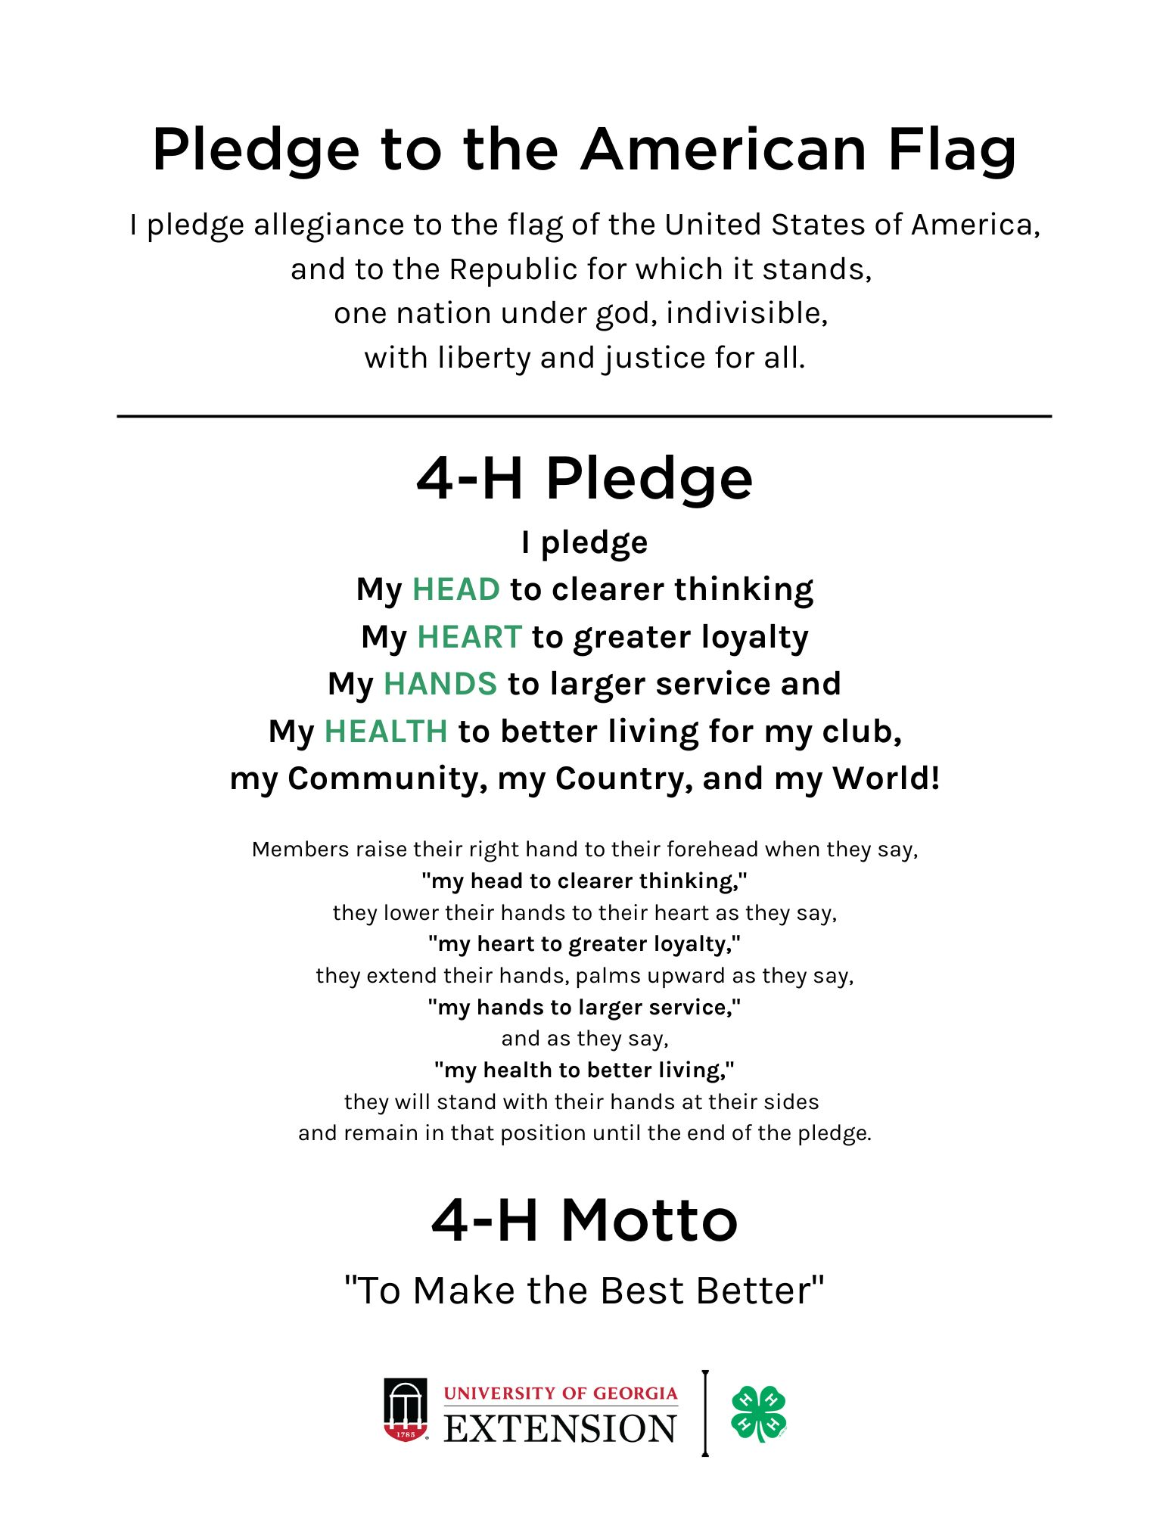

4-H Club Attendance Roster Template
Thank you for participating in a program with UGA Cooperative Extension. We attempt to obtain information from individuals with whom we work to assure that we offer educational programs, assistance, and materials to all people and appreciate your help in this matter. Please complete the following chart per meeting.

To be completed by Staff
Event/ Meeting Date
Program Name
Length of program
Staff present (share names)

To be completed by the attendee
First Name | Last name | Race | Age | Grade | Military Branch
Harry | Potter | White | 13 | 7th | Space Force

*Note: Consider creating a Qualtrics survey or other online survey tools for easier check-in recording and tracking.

Additional Resources
Experimental Learning Model
To continue your learning for hosting quality 4-H club meetings review support the training and article on the Experimental Learning Model.
  - Lesson 8 of 4-H 101 discusses the Experimental Learning Model
    - https://georgia4h.org/wp-content/uploads/Lesson8.pdf
  - University of Florida’s Using an Experimental Model in 4-H article
    - https://edis.ifas.ufl.edu/publication/4H243
Website Support for 4-H Club Meetings
- 4-H Military Partnerships: https://4-hmilitarypartnerships.org/
  - List of Military Liaisons by state
  - Curriculum tools
  - Training Tools
- 4-H Military Partnership: https://www.4-hmilitarypartnership.org/
  - Current training and conferences
  - Military Family and Staff Resources
- Georgia 4-H Military Programs: https://georgia4h.org/programs/focus-areas/citizenship/military-programs/
  - Local and State 4-H Military Programming
  - Curriculum and Lessons
  - Camp Information
- Georgia 4-H Program Areas: https://georgia4h.org/programs/

  - Agriculture and STEM
  - Healthy Living
  - Civic Engagement
  - Summer Camp
  - Project Achievement
  - Club Meetings
  - State Conferences

- Shop 4-H: https://shop4-h.org/
  - Club Meeting Supplies
    - Curriculum
    - Posters
    - Flags

