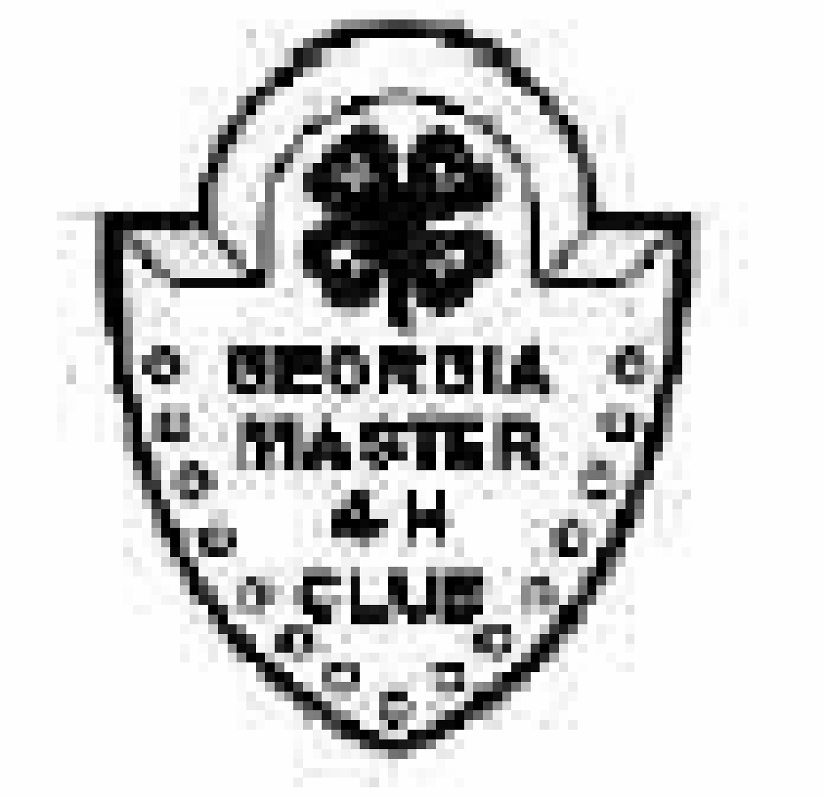

Georgia Master 4-H Club
To Master That Which Has Not Been Mastered

GEORGIA MASTER 4-H CLUB
SPECIAL AWARDS NOMINATION FORM
(Please Type)

Nominee’s Name: ___________________________________________________________
Name to appear on certificate: __________________________________________________
If nominee is employed, give occupation: _________________________________________
If nominee is a student, give grade/year in school: __________________________________
Address: ___________________________________________________________________
Street City State Zip: _________________________________________________________
Phone: __________________________________ Email:_____________________________
County: __________________________
II Please check category for award nomination:
________ Additional Member
________ Honorary Member (Was Never a 4-H Member)
________ Outstanding Master (Current Master 4-H Club Member)
III. Has nominee ever been a 4-H member? Yes _______ # of Years______ No______
County ___________________
IV. Give specific examples of nominees 4-H career accomplishments and/or contributions to 4-H and/or the Master 4-H Club:
______________________________________________________________________________
__________________________________________________________________________________________________________________________________________________________________________________________________________________________________________
__________________________________________________________________________________________________________________________________________________________________________________________________________________________________________
__________________________________________________________________________________________________________________________________________________________________________________________________________________________________________

(Includes continued involvement with 4-H, and for paid staff, over and beyond what would be
expected of an Agent or Program Assistant.)
V. Additional comments:
__________________________________________________________________________________________________________________________________________________________________________________________________________________________________________________________________________________________________________________________________________________________________________________________________________________________________________________________________________________________________________________________________________________________________

VI. Letter of recommendation from Nominator is requested, but not required, as a statement of why nominee is worthy of receiving this award.

VII. For Outstanding Master 4-H Club Member Award Nominees only:
A. Master 4-H Club Membership was earned:
Year __________ County ____________ Project ______________________
B. Describe Contributions to the Master 4-H Club:
________________________________________________________________________________________________________________________________________________________________________________________________________________________________________________________________________________________________________________________________________________________________________________________________________________________________________________________________________________________________________________________________________________________________________________________________________________________________________________

VIII. Nominated by Master 4-H Member or County Extension Director or Agent:
Name of Nominator _______________________________________________________
Address ________________________________________________________________
Phone ____________________________ Email: ________________________________
County _______________________________

Signature of Nominator __________________________________ Date ____________

Application Deadline: May 1
Nominators will be notified by email by May 15

You may email your completed form to gamaster4hawards@gmail.com OR mail completed form to:

Jennifer Nowicki Clark
3565 Ridgefair Dr
Cumming, GA 30040

