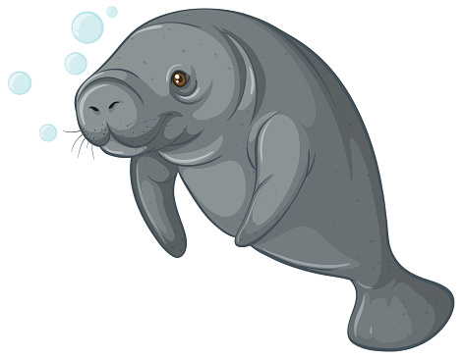  MANATEES  NAME:  DORM: | MANATEES  NAME:  DORM:
MANATEES  NAME:  DORM: | MANATEES  NAME:  DORM:
MANATEES  NAME:  DORM: | MANATEES  NAME:  DORM:
MANATEES  NAME:  DORM: | MANATEES  NAME:  DORM:
MANATEES  NAME:  DORM: | MANATEES  NAME:  DORM:
MANATEES  NAME:  DORM: | MANATEES  NAME:  DORM:
MANATEES  NAME:  DORM: | MANATEES  NAME:  DORM:
MANATEES  NAME:  DORM: | MANATEES  NAME:  DORM:
MANATEES  NAME:  DORM: | MANATEES  NAME:  DORM:

