Greetings Lead Teacher,

Please find this document with Burton 4-H dorm breakdowns as a guide to allocating your adults and students to your assigned dorms.

The maximum bed capacity is 156 beds; however, actual capacity will likely be lower and will depend on gender breakdown and number of schools on-site. We guarantee a bed per person reserved. If your attendance increases, additional space and dorms are not guaranteed. If your attendance decreases, we reserve the right to reassign dorms and learning groups to meet demands for bookings and waitlisted reservations. PLEASE DO NOT ASSUME YOU HAVE ALL THE DORMS.

The dorms available to your group are indicated on the lodging assignment chart in your pre-trip email and noted on your schedule. Your assignment is a recommendation based on the gender ratios submitted for your group. Please plan to maximize beds in each sleeping area (the number of beds in each area is indicated on the dorm breakdown below). Each dorm has a different number of beds available in the “Main Youth Room” and 2 beds available in the “Adult Room.” Please note that although dorms have youth sleeping areas and adult sleeping areas, students can be assigned to adult sleeping areas and adults assigned to students sleeping areas as needed. A few of our dorms are duplex style but are not internally connected.
Please contact the Environmental Educator Program Coordinator if there are questions about your dorm assignments.

Happy planning!

All the best,
Erine-Fay

DORM CAPACITY AND LOCATIONS
Dorm # | Dorm Capacity & Info
 | Gender Assignment | # Showers in Adult Room | # Showers in  Main Room | # Beds in  Adult Room | # Beds in  Main Room | # Total Beds
1 |  | 1 | 3 | 2 (bunk beds) | 26 | 28
2 |  | 1 | 3 | 2 (bunked) | 20 | 22
3A |  | 1 | 2 | 2 | 8 | 10
3B |  | 1 | 2 | 2 | 8 | 10
4 |  | 1 | 2 | 2 | 24 | 26
5 |  | 1 | 2 | 2 | 22 | 24
6 |  | 1 | 2 | 2 | 16 | 18
7 |  | 1 | 2 | 2 | 16 | 18
8  total dorms |  | 8  adult showers | 18  student showers | 16  adult beds | 140  student beds | 156  total beds
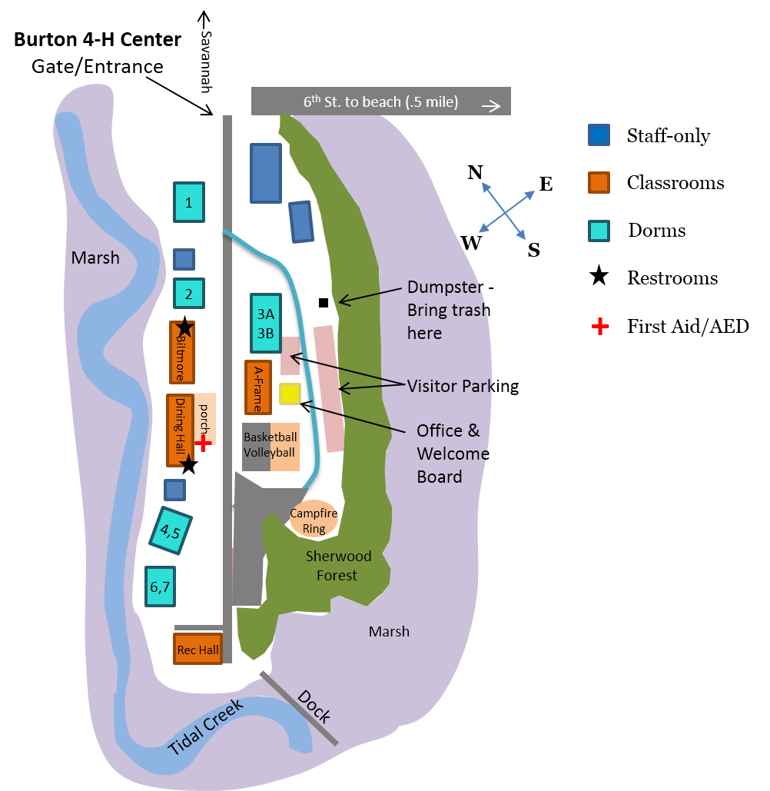

Dorm 1 Assignments

Gender Assigned: __________________ |  | Maximum Sleep Capacity: 28 people
Adult Room (2 beds)
Name | Teacher, chaperone or student? |  | Learning Group
Youth Room (26 beds)
Name | Teacher, chaperone or student? |  | Learning Group
* Youth may be assigned to adult areas, and adults may be assigned to youth areas as needed.

Dorm 2 Assignments

Gender Assigned: __________________ |  | Maximum Sleep Capacity: 22 people
Adult Room (2 beds)
Name | Teacher, chaperone or student? |  | Learning Group
Youth Room (20 beds)
Name | Teacher, chaperone or student? |  | Learning Group
* Youth may be assigned to adult areas, and adults may be assigned to youth areas as needed.

Dorm 3A Assignments

Gender Assigned: __________________ |  | Maximum Sleep Capacity: 10 people
Adult Room (2 beds)
Name | Teacher, chaperone or student? |  | Learning Group
Youth Room (8 beds)
Name | Teacher, chaperone or student? |  | Learning Group
* Youth may be assigned to adult areas, and adults may be assigned to youth areas as needed.

Dorm 3B Assignments

Gender Assigned: __________________ |  | Maximum Sleep Capacity: 10 people
Adult Room (2 beds)
Name | Teacher, chaperone or student? |  | Learning Group
Youth Room (8 beds)
Name | Teacher, chaperone or student? |  | Learning Group
* Youth may be assigned to adult areas, and adults may be assigned to youth areas as needed.

Dorm 4 Assignments

Gender Assigned: __________________ |  | Maximum Sleep Capacity: 26 people
Adult Room (2 beds)
Name | Teacher, chaperone or student? |  | Learning Group
Youth Room (24 beds)
Name | Teacher, chaperone or student? |  | Learning Group
* Youth may be assigned to adult areas, and adults may be assigned to youth areas as needed.

Dorm 5 Assignments

Gender Assigned: __________________ |  | Maximum Sleep Capacity: 24 people
Adult Room (2 beds)
Name | Teacher, chaperone or student? |  | Learning Group
Youth Room (22 beds)
Name | Teacher, chaperone or student? |  | Learning Group
* Youth may be assigned to adult areas, and adults may be assigned to youth areas as needed.

Dorm 6 Assignments

Gender Assigned: __________________ |  | Maximum Sleep Capacity: 18 people
Adult Room (2 beds)
Name | Teacher, chaperone or student? |  | Learning Group
Youth Room (16 beds)
Name | Teacher, chaperone or student? |  | Learning Group
* Youth may be assigned to adult areas, and adults may be assigned to youth areas as needed.

Dorm 7 Assignments

Gender Assigned: __________________ |  | Maximum Sleep Capacity: 18 people
Adult Room (2 beds)
Name | Teacher, chaperone or student? |  | Learning Group
Youth Room (16 beds)
Name | Teacher, chaperone or student? |  | Learning Group
* Youth may be assigned to adult areas, and adults may be assigned to youth areas as needed.

