2019 JUNE DAIRY MONTH
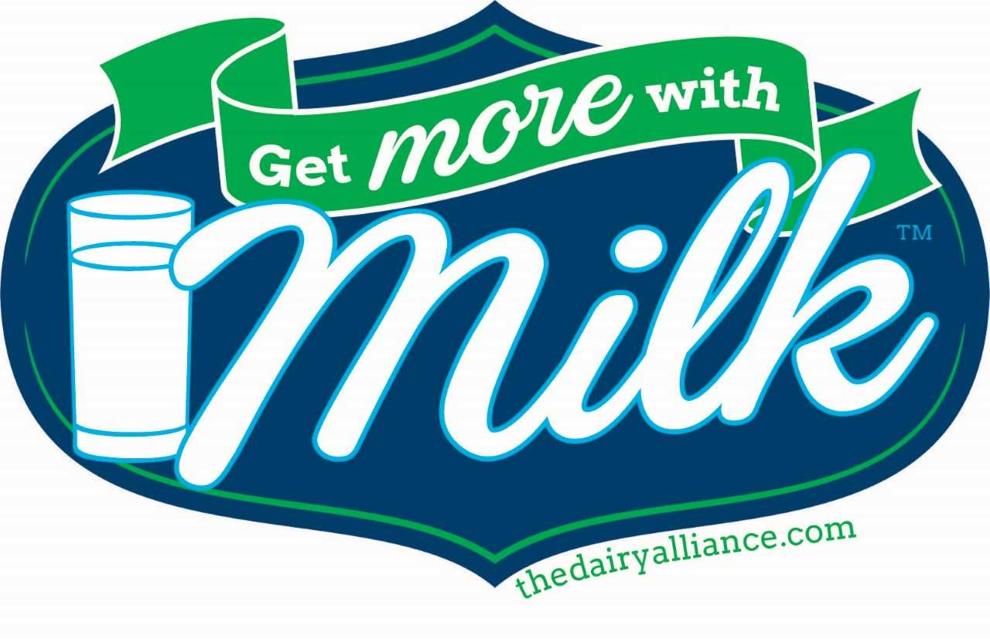
4-H POSTER CONTEST
Who can participate? Every Georgia 4‐H member!

Age groups:
• Cloverleaf: Grades 4 – 6 in current school year
• Junior: Grades 7 – 8 in current school year
• Senior: Grades 9 – 12 in current school year

Why? To learn more about milk and milk products and their importance to human health.

Theme? “Get More With Milk- Dairy is in our DNA!”
How?
1. Poster must be on standard poster board and must be of uniform size ‐ 14” X 22” (half a poster board) ‐ other sizes are ineligible.
2. Follow the theme.
3. Newspaper, film cartoon characters and other copyrighted characters may not be used.
4. Posters should contain only original, hand‐drawn artwork done by the participant. Computer‐generated artwork and text are not acceptable and will result in disqualification of the poster.
5. Do not attach items thicker than the poster board to the poster.
6. Get ideas from television, magazines, parents, and friends. Be creative! Study pictures from your grocery store, a nearby dairy, the Dairy Alliance website (http://thedairyalliance.com), the National Dairy Council (https://www.nationaldairycouncil.org ), or milk cooperatives for additional ideas.
7. Keep it simple and to the point.
8. Complete a contest entry form and tape/paste it on the back of your poster in the upper right corner.
9. Posters are due to your county 4-H office on: _____________________________________________. Your county will then submit a photo of your poster to the state for judging.
10. County 4-H program will display posters in a prominent location in county during the month of June. For example: store windows, town library, school display, extension office.

Scoring Guidelines
Originality – attracts attention, holds interest 40%
Follows theme 20%
Conveys message – easily understood, well- done design 15%
General appearance – well planned, good design; easy to read; neat; no spelling errors 15%
Accurate information – factual 10%
Entries / Winners
Poster entries are due to the county 4-H office by ____________. Your county will submit your poster to the state office. Winners will be announced prior to June 31, 2019.

Prizes
County Winners: All county entries in each age group will receive Georgia 4-H Certificates from their county.
State Winners: Prizes are furnished by our contest donor, The Dairy Alliance. First place ‐ $100 gift card; Second place ‐ $75 gift card; Third place ‐ $50 gift card in each age group.
Sponsored by Georgia 4-H, University of Georgia Cooperative Extension and The Dairy Alliance.

Georgia 4-H June Dairy Month Poster Contest
Official Entry Form

Instructions: Paste or tape this entry form on the back of your poster in
the upper right hand corner. Please print.

Name _________________________________________________________

Street Address__________________________________________________

City, State, Postal Code __________________________________________

Telephone Number ______________________________________________

E-mail Address (if available)_______________________________________

County ________________________________________________________

Teacher or 4-H Club _____________________________________________

Age Category: (Check one)
- Cloverleaf — Grade 4 – 6 in current school year
- Junior — Grade 7 – 8 in current school year
- Senior — Grade 9 – 12 in current school year

Extension Agent Endorsement Statement

I, __________________________ , endorse __________________________
(Name of 4-H Agent or PA) (Name of 4-H Member)
for participation in the Georgia 4-H State June Dairy Month 4-H Poster Contest. This member is currently enrolled in our county 4-H program and meets all qualifications for participation in the event.

