
Rock Eagle Field Study Parent Meeting Notice

Notice to Parents:

On (date), at (time) there will be a parent meeting of ______ grade students in the (location) to discuss the plans and organization of the Environmental Education field study to the Rock Eagle 4-H Center in Eatonton, Georgia. The trip dates are _______________________ to ______________________ . Please make arrangements for at least one parent or guardian to attend. Please sign and return the bottom slip by .
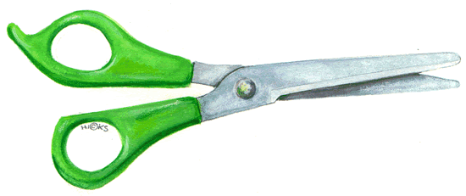
We look forward to seeing you there!
Meeting to Discuss Rock Eagle 4-H Center Study Trip

___________________ will attend

_____________ will not attend

Student’s Name

Signature of Parent or Guardian______________________________________________

Date ____________________

