Chaperones
Please arrange for at least one adult (chaperone or teacher) to accompany each teaching group. The chaperone’s responsibilities are to supervise and discipline students when they are in class, moving between activities, and during free time. Chaperones must be present at all classes, meal times, canteen times, recreation times, and sleep in the cabin with the students. Please meet with chaperones before the trip and cover responsibilities and expectations. We want everyone to feel comfortable, a part of the program, and learn along with the students. The more the chaperones, teachers, and Rock Eagle instructors are informed and work as a team, the smoother the overall experience for everyone. We suggest that you have a chaperone meeting a few weeks before your trip to provide them with guidelines and fill them in on their responsibilities.

Hand out the following items at the chaperones meeting, as well as a list of specific chaperone responsibilities. A sample list is included below. (Add or delete items to meet your school’s needs.)
- Final schedule marked with chaperone’s responsibilities.
- Cabin assignments for chaperones and students. Names of other chaperones and their cabin assignments may be helpful.
- Class groupings.
- Chaperone responsibilities…minimal responsibilities below.
- List of rules and expectations for students.
- Discuss discipline and who is responsible for taking action.
- Discuss first aid procedures.
- Hand out information about what to do in case of emergency and discuss storm/rain plans.
- Emergency contact numbers and contact information. Please inform adults that there are no telephones in cabins and they may not be able to receive calls while at Rock Eagle. All emergency messages will be passed along to adults with the school. Remember there is limited cell phone service at Rock Eagle and cell phones are not permitted during classes.

Chaperone Responsibilities
- Meet with students after getting settled. Go over cabin rules and expectations.
- Supervise assigned activities.
- Supervise students in cabin.
- Supervise students at meals.
- Supervise students during free time.
- Enforce rules for students. Correct students when and if necessary.
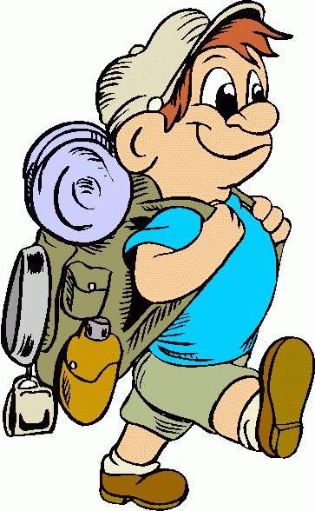
- Make sure all students are in their assigned cabin before lights out.
- Report any disciplinary/school related incidents to the lead teacher from the school.
- Report any maintenance or programming needs to Rock Eagle Staff.
- Before checking out on the last day, be sure students have cleaned the cabin.

