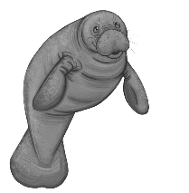
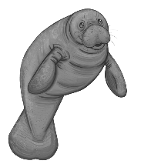
Manatees

Fun Fact: Manatees are marine mammals and usually to come up for air every 3-4 minutes. They have been known to hold their breath for up to 20 minutes!

Adults in This Group: | Dorm # for Each Adult:

Students in This Group: | Dorm # for Each Student:
Total # of Students:
KP Assignment:
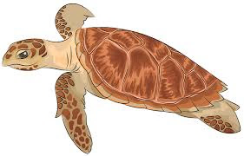
Sea Turtles

Fun Fact: Sea turtles cannot retract their flippers and head into their shells. Their anatomy makes them more agile when under the sea, but highly vulnerable when nesting and hatching.

Adults in This Group: | Dorm # for Each Adult:

Students in This Group: | Dorm # for Each Student:
Total # of Students:
KP Assignment:

Raccoons

Fun Fact: Raccoon have five fingers and can use their hands to collect food, open shells, door or trash cans. They will eat a variety of food including mollusks, insects, berries, eggs, and seeds.

Adults in This Group: | Dorm # for Each Adult:

Students in This Group: | Dorm # for Each Student:
Total # of Students:
KP Assignment:

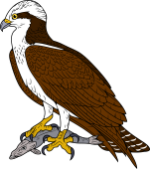
Ospreys

Fun Fact: Ospreys migrate from Canada to South America every year, flying 6,000+ miles.

Adults in This Group: | Dorm # for Each Adult:

Students in This Group: | Dorm # for Each Student:
Total # of Students:
KP Assignment:

Dolphins

Fun Fact: Bottlenose dolphins make a unique signature whistle that may help dolphins recognize each other or communicate. Dolphins even make noises so loud that can stun fish.

Adults in This Group: | Dorm # for Each Adult:

Students in This Group: | Dorm # for Each Student:
Total # of Students:
KP Assignment:

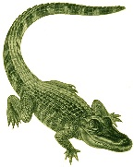
Alligators

Fun Fact: Alligators have between 74 and 80 teeth at any given time, but as teeth fall out they are replaced. An alligator can go through over 2,000 teeth in its lifetime.

Adults in This Group: | Dorm # for Each Adult:

Students in This Group: | Dorm # for Each Student:
Total # of Students:
KP Assignment:

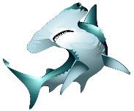
Sharks
Fun Fact: The smallest shark is the dwarf lantern that is only grows to six inches and the largest is the whale shark that grows to a whopping 41.5 feet in length.

Adults in This Group: | Dorm # for Each Adult:

Students in This Group: | Dorm # for Each Student:
Total # of Students:
KP Assignment:

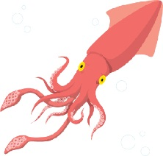
Squids

Fun Fact: Squid have eight arms and two tentacles. Their tentacles are used to capture food.

Adults in This Group: | Dorm # for Each Adult:

Students in This Group: | Dorm # for Each Student:
Total # of Students:
KP Assignment:

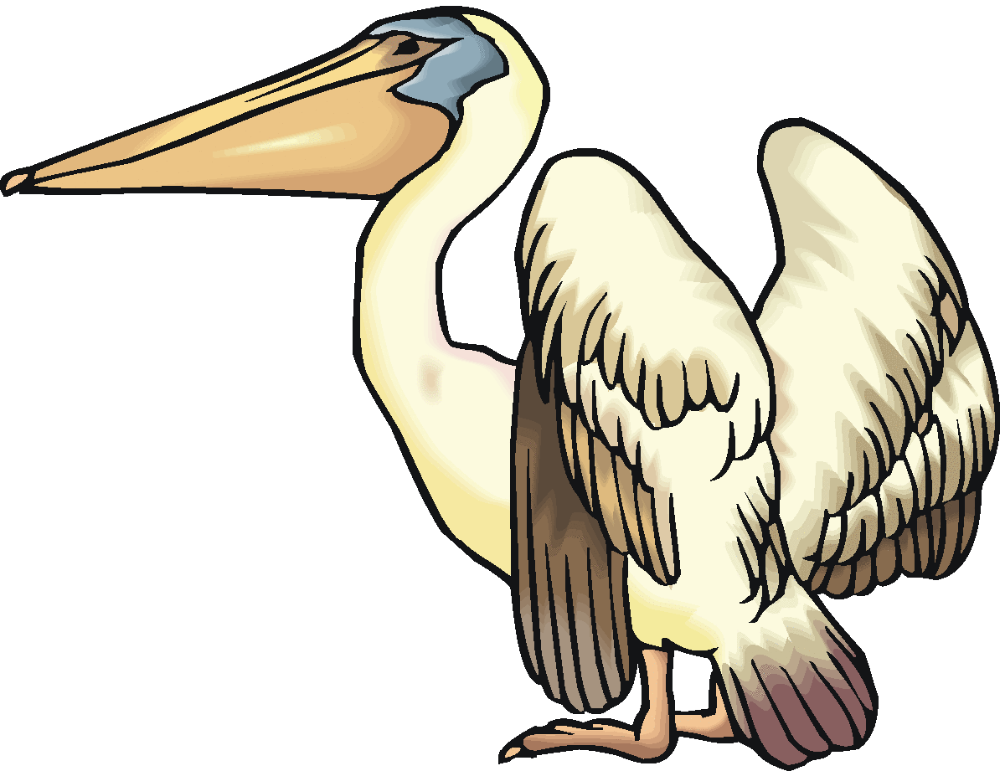
Pelicans

Fun Fact: The large, fibrous skin pouch that dangles from a pelican's bill is called the gular pouch (or, occasionally, the gular sac).

Adults in This Group: | Dorm # for Each Adult:

Students in This Group: | Dorm # for Each Student:
Total # of Students:
KP Assignment:

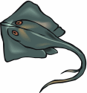
Stingrays

Fun Fact: In ancient Greece, stingray venom was actually extracted from the spines for the purpose of being used as an anesthetic by dentists.

Adults in This Group: | Dorm # for Each Adult:

Students in This Group: | Dorm # for Each Student:
Total # of Students:
KP Assignment:
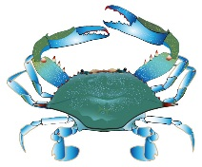
Crabs

Fun Fact: The scientific name for blue crabs is Callinectes sapdius, which means “beautiful savory swimmer.”

Adults in This Group: | Dorm # for Each Adult:

Students in This Group: | Dorm # for Each Student:
Total # of Students:
KP Assignment:

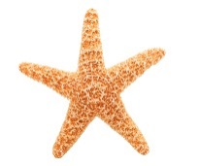
Sea Stars

Fun Fact: There are about 2,000 species of sea stars. Some live in the intertidal zone, while others live in the deep water of the ocean. While many species live in tropical areas, sea stars can also be found in cold areas—even the polar regions.

Adults in This Group: | Dorm # for Each Adult:

Students in This Group: | Dorm # for Each Student:
Total # of Students:
KP Assignment:

