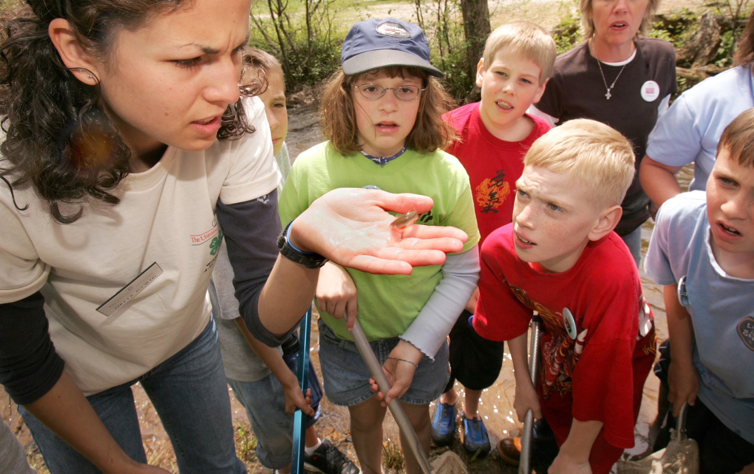

ENVIRONMENTAL EDUCATION PROFESSIONAL DEVELOPMENT

PROJECT WET

PROJECT WILD

PROJECT LEARNING TREE



NOVEMBER 20-21, 2019

AM - 5:00PM DAILY

8:00

FORSTON 4-H CENTER

HAMPTON, GEORGIA

REGISTER ONLINE AT:

[9](https://ugeorgia.ca1.qualtrics.com/jfe/form/SV_3NPchlMZ3HYpFT7)

TINYURL.COM/FORTSON201

Projects WET, WILD, and LEARNING TREE are research-based and field-tested environmental

education curricula designed for use by formal and informal educators. All three programs are

interdisciplinary in nature and support Georgia school standards in science, agriculture/natural

resources, math, social studies, language arts, and more. After successful completion of this

workshop, individuals will be certified educators and will receive guide books which are full of

lessons, resources, and activities. Participants will also enjoy the opportunity to network with

other educators and professionals while engaging in hands-on learning.

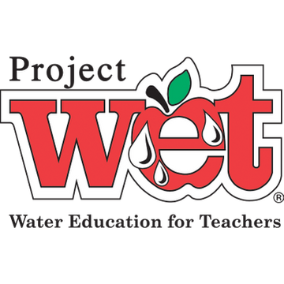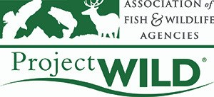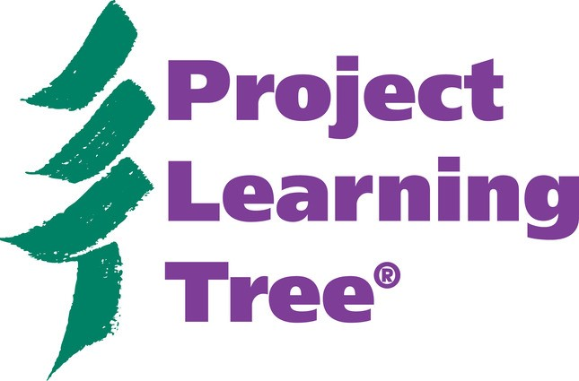

Questions?

Contact Kasey Bozeman, Extension 4-H Specialist

313

Hoke Smith Annex - UGA | Athens, GA 30602 | 706.542.4444 | kaseyb@uga.edu