**Fast Food Meals**

Jordan is hungry for a hamburger for lunch. He wants to make a healthy choice. He knows that he only needs 65 grams of fat and 2000 calories for the entire day, and he needs to get 100% of the vitamins he needs sometime during the day in order to stay healthy. Which burger would be his best choice?

|  |  |
| --- | --- |
| **Nutrition Facts Label**   1. **Wendy’s Single with Cheese and all regular toppings ( lettuce, tomato, pickles, catsup, mustard)**   Serving Size: 1 | |
| Amount Per Serving | |
| Calories 580 | Fat Calories  290 |
|  | % Daily Values* |
| Total Fat 33 grams |  |
| Saturated Fat 14.0 |  |
| Trans Fat  1.5 |  |
| Sodium 1240 mg |  |
| Calcium | 20% |
| Vitamin C | 10% |
| Vitamin A | 15% |
| Protein 31 grams |  |
|  | |

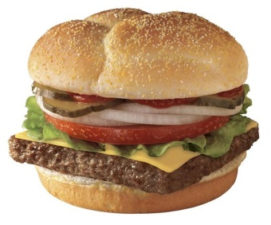

|  |  |
| --- | --- |
| **Nutrition Facts Label**   1. **Wendy’s Baconator Sandwich**   Serving Size: 1 | |
| Amount Per Serving | |
| Calories 790 | Fat Calories  430 |
|  | % Daily Values* |
| Total Fat 48 grams |  |
| Saturated Fat 13.0 |  |
| Trans Fat  2.5 |  |
| Sodium 1410 mg |  |
| Calcium | 20% |
| Vitamin C | 0% |
| Vitamin A | 10% |
| Protein 50 grams |  |
|  | |



|  |  |
| --- | --- |
| **Nutrition Facts Label**   1. **Wendy’s Junior Cheeseburger Deluxe**   Serving Size: 1 | |
| Amount Per Serving | |
| Calories 350 | Fat Calories  170 |
|  | % Daily Values* |
| Total Fat 19 grams |  |
| Saturated Fat 7.0 |  |
| Trans Fat  1.0 |  |
| Sodium 850 mg |  |
| Calcium | 10% |
| Vitamin C | 6% |
| Vitamin A | 10% |
| Protein 17 grams |  |
|  | |



|  |  |
| --- | --- |
| **Nutrition Facts Label**   1. **Wendy’s Junior Cheeseburger**   Serving Size: 1 | |
| Amount Per Serving | |
| Calories 285 | Fat Calories  115 |
|  | % Daily Values* |
| Total Fat 13 grams |  |
| Saturated Fat 6.0 |  |
| Trans Fat  .75 |  |
| Sodium 820 mg |  |
| Calcium | 13% |
| Vitamin C | 1% |
| Vitamin A | 4% |
| Protein 17 grams |  |
|  | |



Fast Food Reasons

Ranking: 3,4,1,2

3 over 4 because 3 has lettuce and tomato so is higher in vitamin A and vitamin C. Granted 4 is lower in fat and calories and higher in calcium.

4 over 1 because 4 is lower in fat, calories and sodium. Granted 4 is also lower in Vitamin A, Vitamin C and calcium.

1 over 2 because 1 is lower in calories, fat, and sodium, and higher in Vitamin A and Vitamin C. Granted calcium is the same.