**Simple Surveys:**

**Standard Survey**

**Data Calculation Tabulation Spreadsheet**

**Instructions**

There are three sheets in this Data Calculation Tabulation Template: Getting Started, Questionnaire Template, and Demographic_OpenEnded. All data tabulation and analysis are presented on the Questionnaire Template sheet. Different sections within the sheet will be referred to throughout these instructions.

**Entering Data**

1. Enter Questionnaire Title (Purple Section)
2. Enter Questionnaire Questions (Blue Section)
   1. Entering the text of the questions is optional. If you do not enter the questions, be sure you can identify which survey questions correspond with the questions as labeled on the spreadsheet (Question 1, Question 2, etc.)
3. Enter the number of you Likert Scale Options (Gray Section).
   1. **You must enter your scale in the appropriate cell (Ex. 4, 5, etc.) in order for the DataTabulation section to be complete and accurate.**
   2. You should also indicate word associations (Ex. Very Unsatisfied, Unsatisfied, Neutral, Satisfied, Very Satisfied) with your values (Gray Section).
4. Enter Participant Identification (Orange Section)
   1. The spreadsheet has 1,500 participants identified using the following naming convention: Participant 1, Participant 2, etc. You may change this if desired. We recommend numbering your individual surveys to correspond with the data entry. This will ease data entry and enable you to reference surveys as needed.
5. Enter Additional Identifier (County, District, etc.). You may leave this blank or choose any type of identifier. (Orange Section)
6. Enter Questionnaire data/Participant Responses (Green Section)
   1. Enter each answer from one participant and simply tab over to enter their next response.
   2. This template was designed for a standard set of questions that correspond with the following:
      1. Numerical value assigned to the Likert response is ascending with the desirable answer on the high end of scale (Ex. 1=Strongly Disagree, 2=Disagree, 3=Agree, 4=Strongly Agree). Entering this incorrectly will affect “% of Participants Gain” and “% who Agree or Strongly Agree.” This assumes that your survey questions are positively worded. To account for negatively worded questions, adjust your scores so the most desirable answer is largest (Ex. Strongly Disagree=4). Please contact us if you would like assistance adjusting the survey or data entered to take into account negatively worded questions or other related issues.
7. Enter any additional information concerning your specific questionnaire
   1. Enter your total possible participants (Gray Section). *This is not the same as total participants; this number should indicate the number of questionnaires that were handed out, not the number that were returned.* If you do not enter a number here, the Response Rate (Dark Pink section) will not be calculated.
   2. It is recommended if you have additional data to enter, like demographic information and/or short answer questions and responses that you enter this information on an additional tab within the spreadsheet. By doing this you ensure that your additional data will not interfere with formulas embedded in the data sheet. An additional sheet is provided (Demographic_OpenEnded) for this purpose. This sheet can be modified easily to match your survey.

**Analyzing/Tabulating Data**

1. Once data has been entered, the data tabulation section of the spreadsheet should have modified to produce your new values (Dark Pink Section).

**Modifying Template (Optional, For Advanced Users)**

1. Unlock the cells in the DataTabulation section of the Questionnaire Template sheet (Dark Pink and some Gray sections) by clicking Home🡪Format (Cells group)🡪Unprotect Sheet (this unlocks the locked cells on the sheet so that you can, modify formulas, add questions, increase number of participants, etc.)
2. You will have to modify the existing formulas if:
   1. Your participant list is more than 1,500 individuals. All formulas are entered to include participants from Row 25 - Row 1524. If your participant list increases past 1,500, modify the following formulas in the Data Tabulation Section (Dark Red) by adjusting the last cell value to your new cell value (Ex. B25:B1524 will be B25:B1624 to accommodate 100 more participants). This needs to be modified in the following sections:
      1. Total Points Received
      2. Mean
      3. Standard Deviation
      4. % Who [Top Two Most Desirable Answers)
   2. You have more than 10 questionnaire questions. If you need to enter a new question into the questionnaire, you will need to add a column in the Data Tabulation (Dark Pink Section). Formulas for each question are given below. Reminder: Enter formulas into the cell beginning from the = sign.

Total Received Formula: =sum(all question 1 responses)

Total Points Possible (Question Max Score x # of Participants)🡪 Contact Jeff

Buckley or Jennifer Cantwell for the formula

Mean/Average Formula: =average(total received/total possible)

Standard Deviation Formula: =stdev(all question 1 responses)

Response Rate (#questionnaires returned/total program participation)

**Reporting Data**

Reporting Data is one of the most important efforts in questionnaires. By reporting your results, you have the ability to identify areas for program improvement, make changes to survey questions as needed, show program progress and impact, and potentially secure funding for programming.

When sharing the tabulated results, be cognizant of how your data can be used and do not overstate the results. These surveys are designed to be shared with stakeholders and funders as well as to support program improvement. They are not considered research and do not necessarily prove direct causality and cannot be generalized. For example, you cannot state that the results are a direct result of participation in your program or that if other organizations implement your program they will receive the same results. If you would like to pursue this level of evaluation or research, please contact your local Institutional Review Board as appropriate. Please feel free to contact us to discuss this more in-depth.

Some examples on how to transfer data from a spreadsheet into a report are given below. Please tailor these comments to your specific data set, and personalize them to make them more effective in your report. A Questionnaire Template, including the questions are shown for reference.

Questionnaire Template, Data Entry Section:

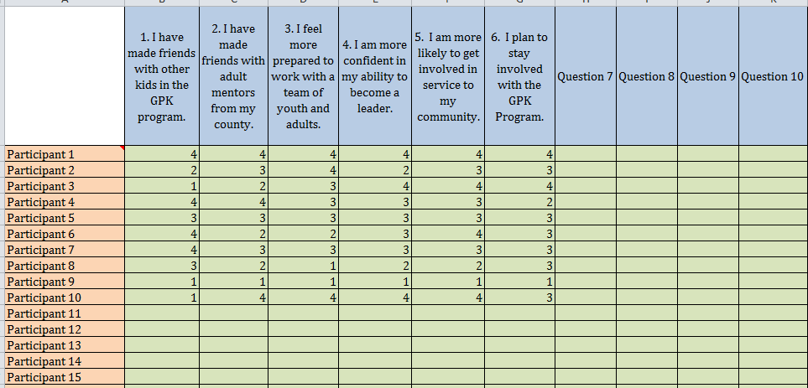

Questionnaire, Data Tabulation Section:

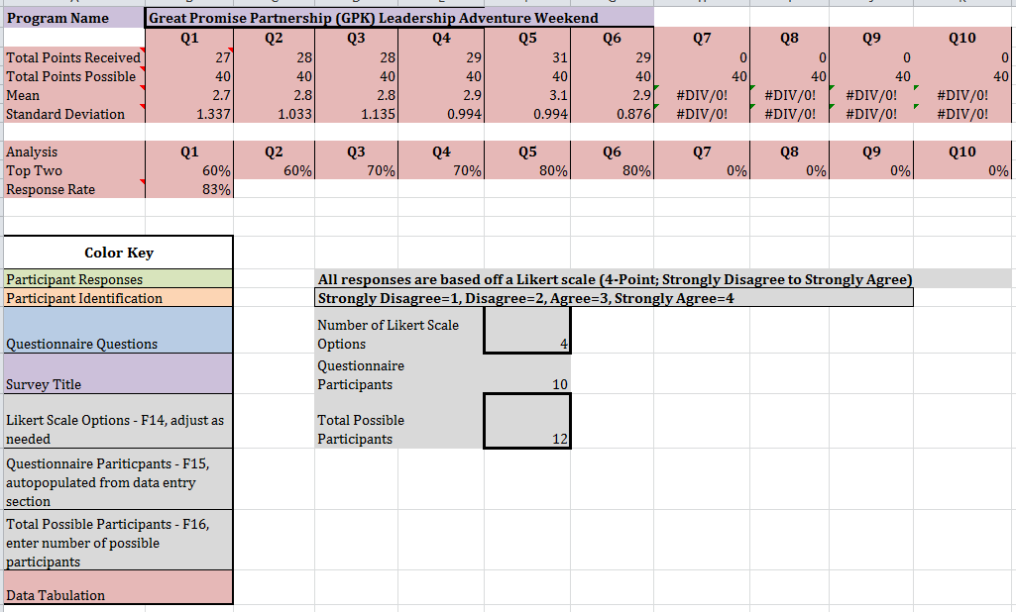

Report Data Results by using comments like:

* 70% of youth that indicated they agreed or strongly agreed that they are more likely to get involved in their community as a result of the GPK Leadership Adventure Weekend. [Question 5]
* From Question 1, we find that 70% of respondents “agreed” or “strongly agreed” that they had made friends with other kids in the GPK program.

If you had a high percentage of respondents that agreed or strongly agreed on every question, you could provide a general outcome statement related to your overall program goal(s) (see below) then provide specific results/impact statements in support, like those above.

* The majority of youth participating in Great Promise Partnership (GPK) Leadership Adventure Weekend indicated they made positive connections and feel confident about their ability to be a contributing member of their community. Specifically, [add question-specific results such as those above].

Depending on your audience, you could also utilize the other results provided, including mean and standard deviation.

For additional information or assistance please contact:

Jeff Buckley – Extension 4-H Faculty

Global & Citizenship Programs

University of Georgia

320 Hoke Smith Annex

Athens, GA 30602-4356

Office: (706) 542-8735

Fax: (706) 542-4373

[jbuckley@uga.edu](mailto:jbuckley@uga.edu)

Jennifer E. Cantwell, MSW – Extension Program Coordinator

AmeriCorps & Program Evaluation

University of Georgia

328 Hoke Smith Annex

Athens, GA 30602-4356

Office: (706) 542-4294

Fax: (706) 542-4373

[jecantw@uga.edu](mailto:jecantw@uga.edu)