Placemat Apron

Materials:
- 2 purchased fabric placemats
- 3 yards 5/8-inch grosgrain ribbon
- 24 inches of ribbon for neck (adult) (less if for a smaller child)
- Two 30-inch strips of ribbon for waist (longer if needed)
- 24 inches of ribbon to use for trim

Directions:
- Fray Check™ the cut ends of the ribbon.

- Find the center of the upper placemat along the long side of the placemat. Mark the center edge with a pin and the center of the placemat near the middle with a pin.
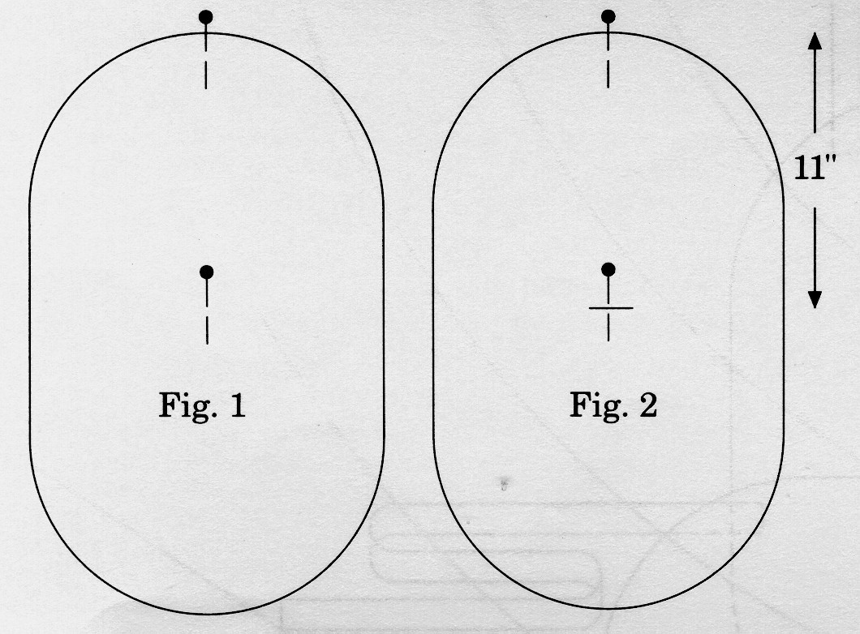
- Measure 11 inches from the edge along the center line and place a pin or make a mark with a disappearing ink pen.

- For the waist ribbons:

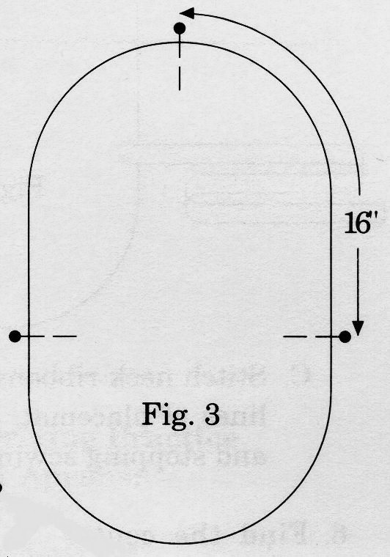
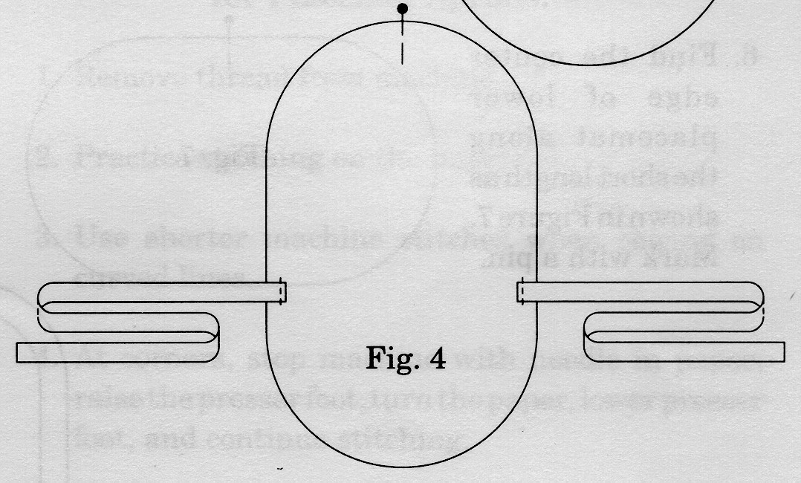
- Measure around the outside edge of the placemat from the pin at center edge 16 1/4 inches and place a pin or a mark. Do the same on the other side of the placemat. Set Figure 3. This is for the waist ribbons.

- On the right side of the placemat, position the waist ribbons as shown in Figure 4. Stitch along the stitching lines on the placemat. Backstitch when starting and stopping the stitching.

- For the neck ribbons:
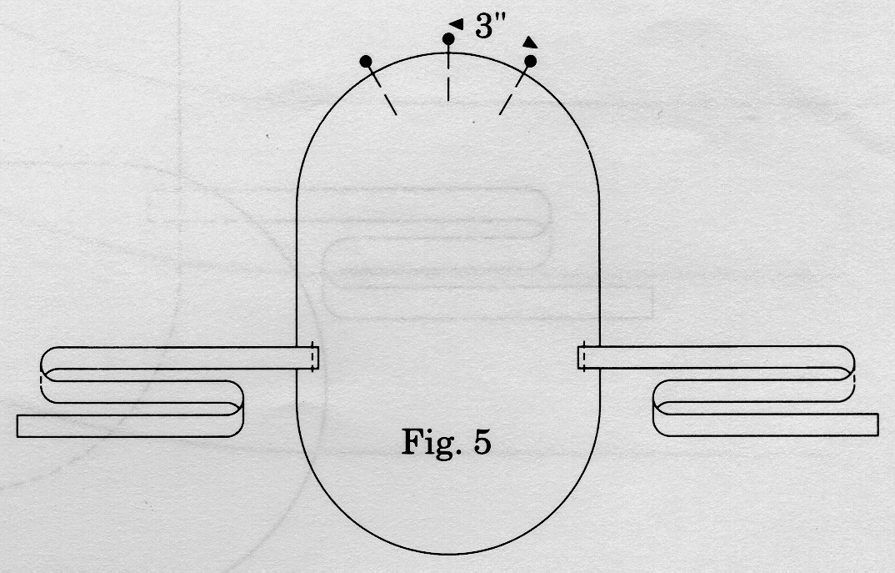
- Measure 3 inches to the right of the pin at center edge and place a pin or make a mark. Do the same to the left of center.

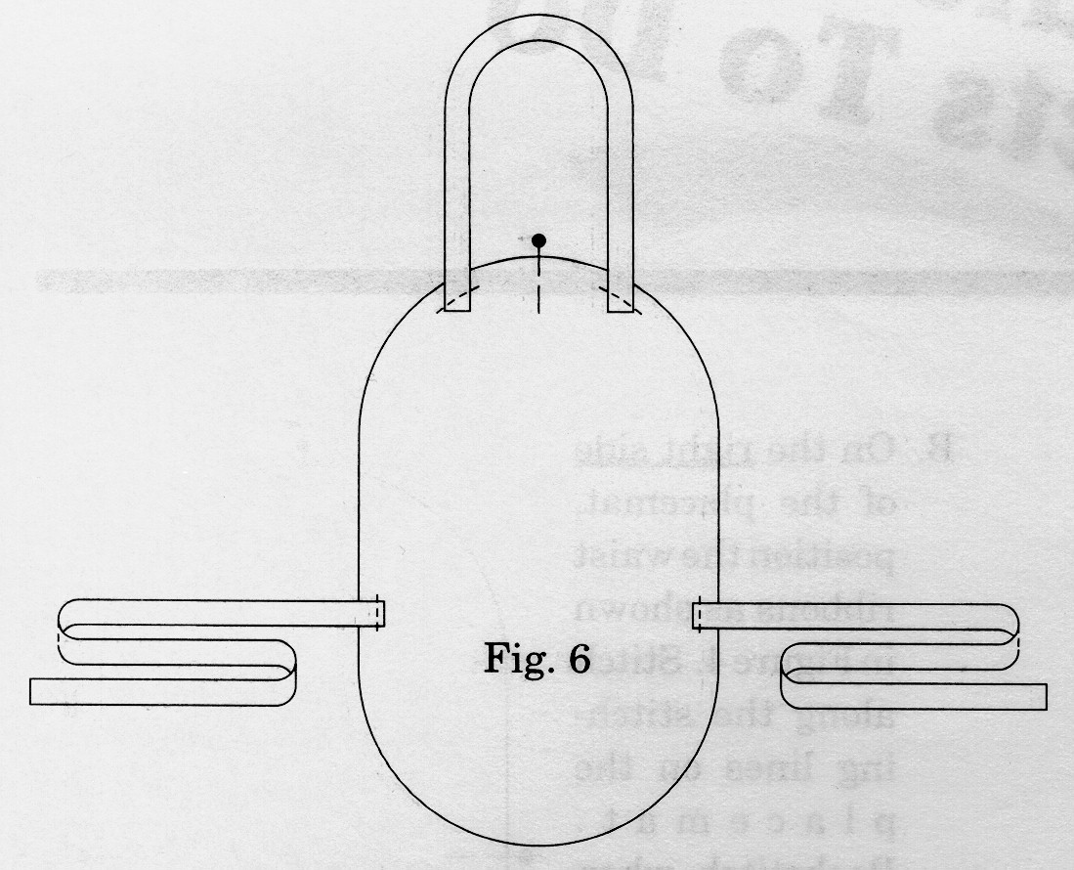
- Place neck ribbons on wrong side of placemat, about 1-3/4 inches below the edge of the placemat as shown in Figure .6

- Stitch neck ribbons by sewing along stitching lines of placemat. Backstitch when starting and stopping sewing.
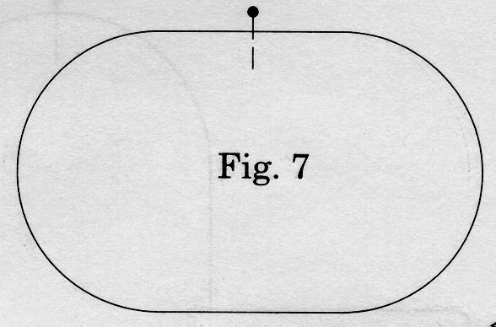
- Find the center edge of lower placemat along the short length as shown in Figure 7. Mark with a pin.
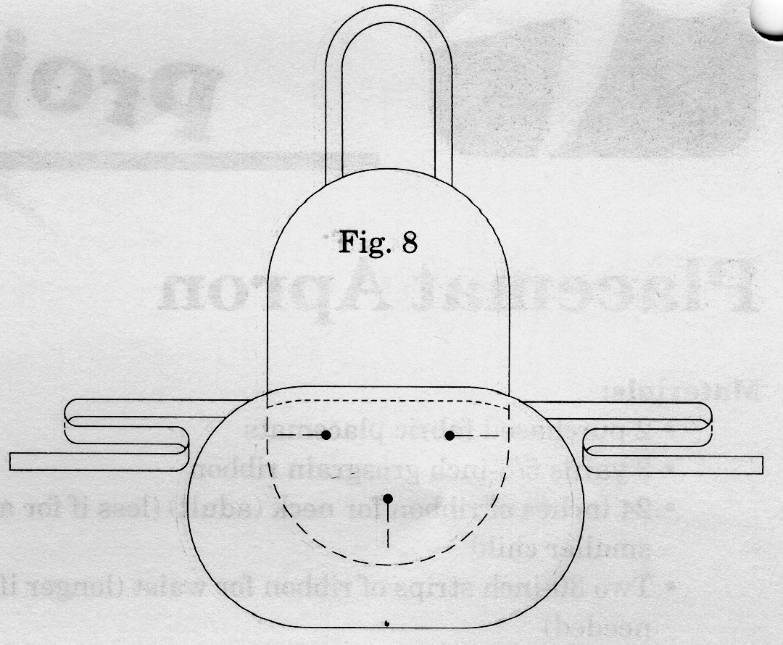
- Place the lower placemat on the upper placemat, lining up center pins and 11 inch mark as well as upper edges of waist ribbon on either side of upper placemat.

- Place three pins through both placemats to hold them from moving as shown in Figure 8.

- On the wrong side of the placemats, stitch along the stitching line of the placemat. Bartack at the beginning and ending of stitching to reinforce the pocket. This row of stitching forms the pocket.
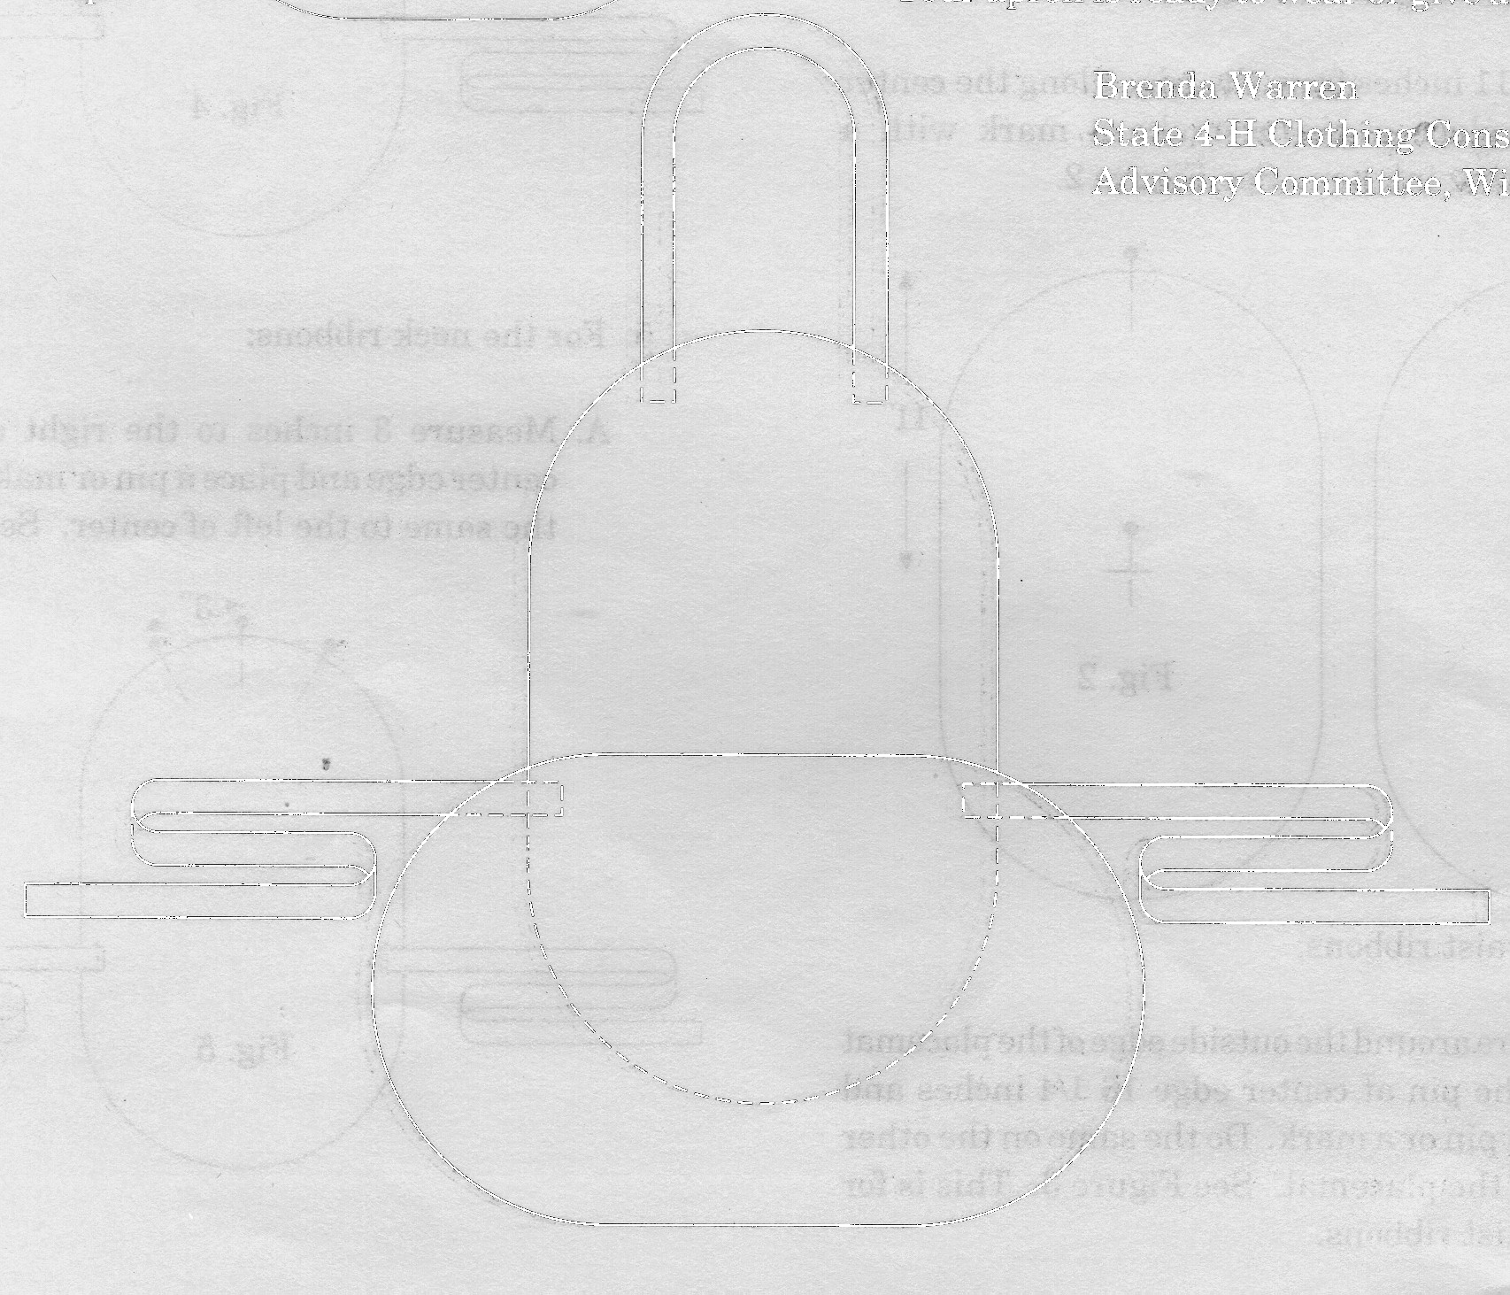
Your apron is ready to wear or give as a gift. Enjoy!

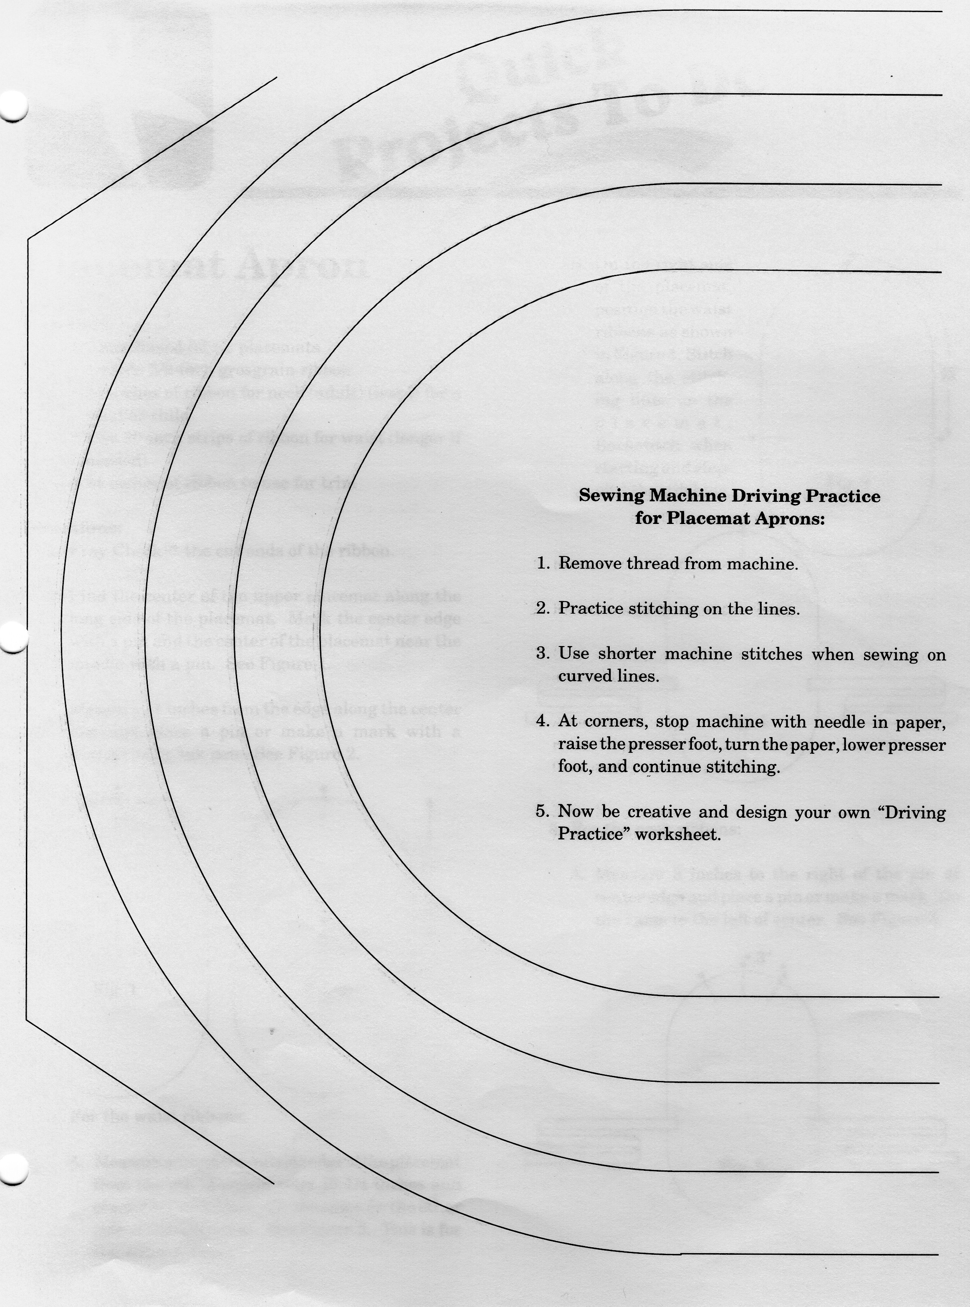

Provided by Wisconsin 4-H

