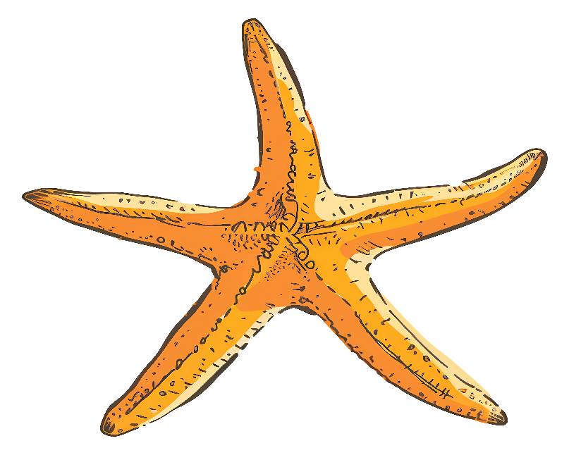    SEA STARS  NAME:  DORM: | SEA STARS  NAME:  DORM:  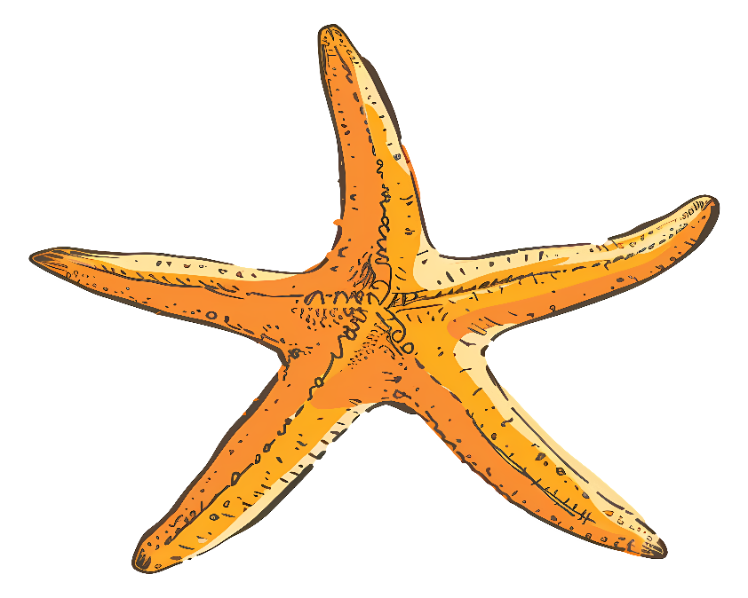
SEA STARS  NAME:  DORM: | SEA STARS  NAME:  DORM:
SEA STARS  NAME:  DORM: | SEA STARS  NAME:  DORM:

SEA STARS  NAME:  DORM: | SEA STARS  NAME:  DORM:
SEA STARS  NAME:  DORM: | SEA STARS  NAME:  DORM:
SEA STARS  NAME:  DORM: | SEA STARS  NAME:  DORM:

SEA STARS  NAME:  DORM: | SEA STARS  NAME:  DORM:
SEA STARS  NAME:  DORM: | SEA STARS  NAME:  DORM:
SEA STARS  NAME:  DORM: | SEA STARS  NAME:  DORM:

