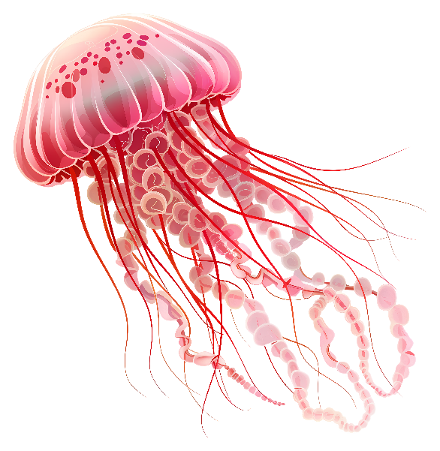    JELLYFISH  NAME:  DORM: | JELLYFISH  NAME:  DORM:
JELLYFISH  NAME:  DORM: | JELLYFISH  NAME:  DORM:
JELLYFISH  NAME:  DORM: | JELLYFISH  NAME:  DORM:

JELLYFISH  NAME:  DORM: | JELLYFISH  NAME:  DORM:
JELLYFISH  NAME:  DORM: | JELLYFISH  NAME:  DORM:
JELLYFISH  NAME:  DORM: | JELLYFISH  NAME:  DORM:

JELLYFISH  NAME:  DORM: | JELLYFISH  NAME:  DORM:
JELLYFISH  NAME:  DORM: | JELLYFISH  NAME:  DORM:
JELLYFISH  NAME:  DORM: | JELLYFISH  NAME:  DORM:

