Josh is a freshman at the University of Georgia. He did not bring any of his ties with him to college. He has just been asked to be a date to a semi-formal dance. The event is tomorrow night. Josh has to buy a new tie that does not exceed the price of $45.00. He has his car so is able to drive in Athens to purchase the tie. He does not think that he make an online purchase in case it does not arrive in time. Josh is looking for a colorful tie or bowtie.

Belk
Saddlebred Extra Long Derby Basketweave Tie
$24.99 (On Sale from $45.00)

Description:
- Extra Long
- Silk
- Exclusively Sold at Belk
- Imported into US
- Dry Clean only

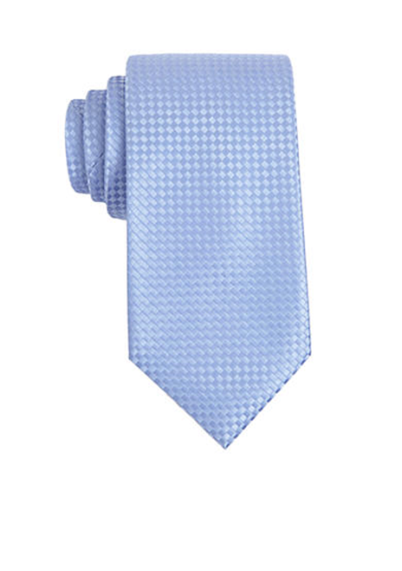

Macy’s Atlanta
Alfani Men’s Ludlow Geometric Bow Tie
$55.00

Description:
- Bow Tie and pocket square set
- Geometric pattern bow tie
- Solid pocket square
- Only available at Macy’s
- Silk
- Dry Clean only
- Imported to US

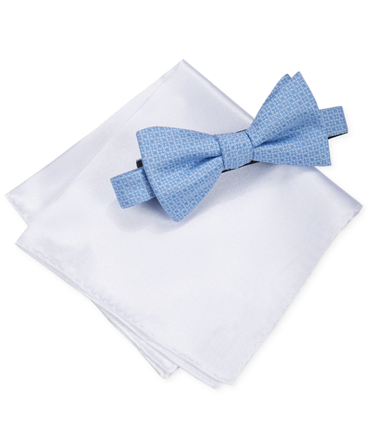

Vineyard Vines
Corgi Tie
$45.00

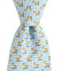

Descriptions:
- 100% Silk
- Double wool-blend liner
- Soft, delicate fabric
- 59” inch regular tie length
- Handmade in USA
- Dry clean or spot clean only

Onward Reserve
Collard-Greens Newman Tie - Salmon/Carolina
$65.00
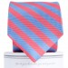

Descriptions:
- Handmade In New York City
- 58 1/2 inches in length
- 3 1/4 inches in width at widest part of tie
- Packaging doubles as a travel case for up to two neckties
- Dry Clean only

1,3,4,2
Top Pair | Reason For Placing | Grant | Fault
(1,3) | 1) Matches all necessary requirements. It can be found in Athens. Is a straight, bright color and is within the price range. Also is well made and will last in good condition for longer. | 3) Can be found in Athens. Of bright, color. Well-made so will last in good condition for a long time. In Price range | 3)wool liner would make it hot at times.
Middle Pair
(3,4) | 3) Can be found in Athens. Meets requirement of color, pattern and price. Will stay in good condition. | 4) Can be found in Athens. Will last in good condition for long time as well made. colorful | 4) Out of price range.
Bottom Pair
(4,2) | 4) Can be found in Athens. Will last in good condition for long period of time and is colorful. | 2) Has color. Well made and will last in good condition for a long time. Bowtie good for formal occasion | 2) Cannot be found in Athens. Is out of price range.

