******Simple Surveys:**

**Retrospective Post-then-Pre**

**Data Calculation Tabulation Template**

**Instructions**

There are five sheets in this Data Calculation Tabulation Template: Getting Started, DataEntry, DataTabulation, Demographics_OpenEnded, and DataCalculation. The following instructions will refer to sections within these sheets. The DataCalculation spreadsheet is where the “% gained data” is calculated. This sheet should not be modified.

**Entering Data**

1. Enter Questionnaire Title (Purple Section on DataTabulation sheet)
2. Enter Questionnaire Questions (Blue Section on DataEntry sheet)
   1. Entering the text of your questions into the spreadsheet is optional. If you do not enter the questions, be sure you can identify which survey questions correspond with the questions as labeled on the spreadsheet (Q1Pre, Q1 Post, Q2 Pre, Q2 Post, etc.).
3. Enter the number of your Likert Scale Options (DataTabulation sheet, Gray Section)
   1. **You must enter your scale in the appropriate cell (Ex. 4, 5, etc.) in order for the DataTabulation section to be complete and accurate.**
   2. You should also indicate word associations (Ex. Very Unsatisfied, Unsatisfied, Neutral, Satisfied, Very Satisfied) with your values (Gray Section, DataTabulation sheet).
4. Enter Participant Identification (Orange Section on DataEntry sheet)
   1. The spreadsheet has 1,500 participants identified using the following naming convention: Participant 1, Participant 2, etc. You may change this if desired. We recommend numbering your individual surveys to correspond with the Participant Identification (i.e. 1=Participant 1). This will ease data entry and enable you to reference surveys as needed.
5. Enter Additional Identifier (County, District, etc.). You may leave this blank or choose any type of identifier. (Orange Section)
   1. This can be helpful if you would like to present complete results and filter by county, district, classroom, etc.
6. Enter Questionnaire Data/Participant Responses (Green Section on DataEntry sheet)
   1. Enter each answer from one participant for each and simply tab over to enter their next response.
   2. Since this is a retrospective post-then-pre questionnaire, each question will have two responses. Make sure to pay special attention when entering your data, so you do not confuse results and produce false data. *Note: You could use the Simple Survey Post-test only survey as a pre and posttest and enter the data in this Data Calculation Template.*
   3. This template was designed for a standard set of questions that correspond with the following:
      1. Numerical value assigned to the Likert response is ascending with the desirable answer on the high end of scale (Ex. 1=Strongly Disagree, 2=Disagree, 3=Agree, 4=Strongly Agree). Entering this incorrectly will affect “% of Participants Gain” and “% who Agree or Strongly Agree.”
      2. This assumes that survey questions are positively worded. To account for negatively worded questions, adjust your scores so the most desirable answer is largest (Ex. Strongly Disagree=4). Please contact us if you would like assistance adjusting the survey or data entered to take into account negatively worded questions or other related issues.
7. Enter any additional information concerning your specific questionnaire.
   1. Enter your total possible participants if desired (Gray Section, DataTabulation sheet). *This is not the same as total participants; this number should indicate the number of questionnaires that were handed out, not the number that were returned.* If you do not enter a number here, the Response Rate (Dark Pink Section, DataTabulation sheet) will not be calculated.
   2. It is recommended if you have additional data to enter, like demographic information and/or short answer questions and responses that you enter this information on an additional sheet within the spreadsheet. By doing this you ensure that your additional data will not interfere with formulas embedded in the data sheet. An additional sheet is provided (Demographic_OpenEnded) for this purpose. This sheet can be modified easily to match your survey.

**Analyzing/Tabulating Data**

1. Once data has been entered, the data tabulation section of the spreadsheet should have modified to produce your new values (Dark Pink section, DataTabulation sheet).

**Modifying Template (Optional, For Advanced Users)**

1. Unlock the DataTabulation worksheet by clicking Home🡪Format (Cells group)🡪Unprotect Sheet (this unlocks the entire sheet so that you can add questions, modify formulas, increase number of participants, etc.)
2. You will have to modify the existing formulas if:
   1. Your participant list is more than 1,500 individuals. All formulas are entered to include participants from Row 2 - Row 1501 on the DataEntry sheet. If your participant list increases past 1500, modify the following formulas in the Data Tabulation Section (Dark Pink Section, Data Tabulation sheet) by adjusting the last cell value to your new cell value (Ex: C2:C1501 will be C2:C1601 to accommodate 100 more participants). This needs to be modified in the following sections for each question:
      1. Total Points Received
      2. Mean
      3. Standard Deviation
      4. % of Participants Gain
      5. % Who [Top Two Most Desirable Answers]
   2. You have more than 10 questionnaire questions. If you need to enter a new question into the questionnaire, you will need to add a column in the Data Tabulation for each question (Dark Pink Section, DataTabulation sheet). Formulas for each question are given below. Reminder: Enter formulas into the cell beginning from the = sign.

Total Received Formula: =sum(all question 1 responses)

Total Points Possible (Question Max Score x # of Participants)🡪 Contact Jeff

Buckley or Jennifer Cantwell for the formula

Mean/Average Formula: =average(total received/total possible)

Standard Deviation Formula: =stdev(all question 1 responses)

Response Rate (#questionnaires returned/total program participation)

**Reporting Data**

Reporting Data is one of the most important efforts in questionnaires. By reporting your results, you have the ability to identify areas for program improvement, make changes to survey questions as needed, show program progress and impact, and potentially secure funding for programming.

When sharing the tabulated results, be cognizant of how your data can be used and do not overstate the results. These surveys are designed to be shared with stakeholders and funders as well as to support program improvement. They are not considered research and do not necessarily prove direct causality and cannot be generalized. For example, you cannot state that the results are a direct result of participation in your program or that if other organizations implement your program they will receive the same results. If you would like to pursue this level of evaluation or research, please contact your local Institutional Review Board as appropriate. Please feel free to contact us to discuss this more in-depth.

Some examples on how to transfer data from a spreadsheet into a report are given below. Please tailor these comments to your specific data set, and personalize them to make them more effective in your report. The questions, DataEntry page and DataTabulation page related to the examples are shown for reference.

Junior/Senior District Project Achievement Survey

I am confident in my ability to:

Q1: Research information for a specific topic utilizing a variety of methods.

Q2: Develop knowledge in the subject area that I chose for my project.

Q3: Paraphrase and summarize information without plagiarizing.

Q4: Separate facts from opinions about a subject.

Q5: Develop a balanced view about a topic by reviewing different perspectives.

Q6: Prepare an outline and organize information under topics and sub topics for a presentation.

Q7: Speak in front of an audience.

DataEntry sheet:

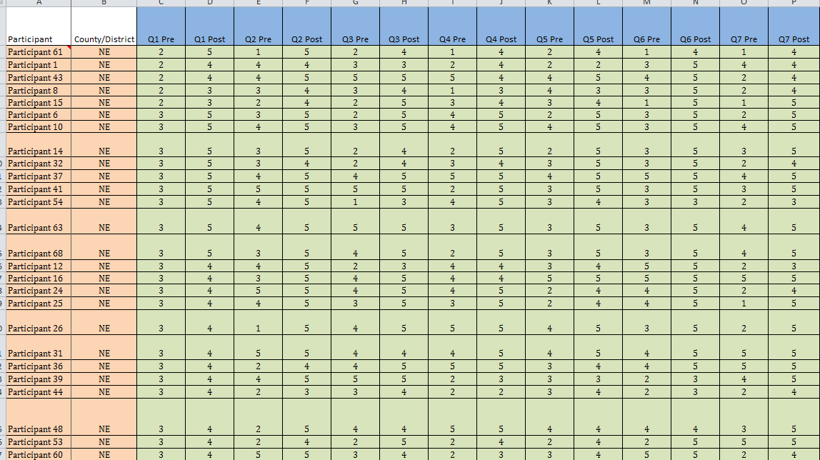

DataTabulation sheet:

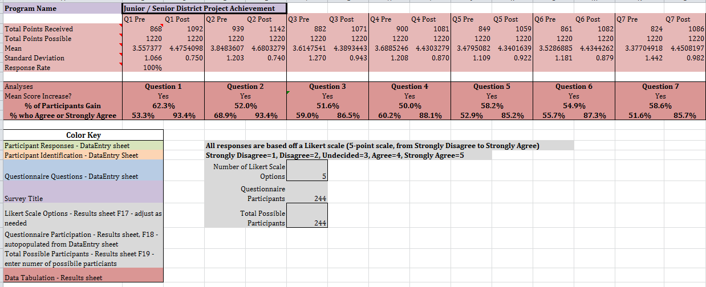

Report Data Results by using comments like:

* In Question 2, 52% of youth indicated an increase in their confidence concerning their ability to develop knowledge in the subject area they chose for their project.
* The percentage of youth who agreed or strongly agreed that they were confident in their ability to develop knowledge in their chosen project subject area increased from 68.9% before participating in Project Achievement to 93.4% after participation.
* 58.6% of youth had an increase in confidence in their ability to speak in front of an audience.

If there were positive gains for each category, you could provide a general outcome statement related to your overall program goal(s) (see below) then provide specific statements to support that comment, like those above:

* Youth participating in Junior/Senior District Project Achievement reported an increase in knowledge of best practices in public speaking and/or confidence in public speaking. Specifically, [add question-specific results such as those above].

Depending on your audience, you could also utilize the other results provided, including mean and standard deviation.

For additional information or assistance please contact:

Jeff Buckley – Extension 4-H Faculty

Global & Citizenship Programs

University of Georgia

320 Hoke Smith Annex

Athens, GA 30602-4356

Office: (706) 542-8735

Fax: (706) 542-4373

[jbuckley@uga.edu](mailto:jbuckley@uga.edu)

Jennifer E. Cantwell, MSW – Extension Program Coordinator

AmeriCorps & Program Evaluation

University of Georgia

328 Hoke Smith Annex

Athens, GA 30602-4356

Office: (706) 542-4294

Fax: (706) 542-4373

[jecantw@uga.edu](mailto:jecantw@uga.edu)