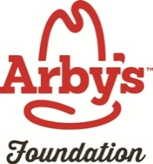  

**Arby’s Foundation, Georgia Food Bank Association & Georgia 4-H   
Pantry Pride Recipe Contest**

**Contest Goals:**

1. Raise awareness among 4-H’ers about poverty, hunger and the underprivileged in Georgia.

2. Challenge 4-H’ers to think creatively about food and cooking by developing or reinventing recipes using ingredients commonly found in Georgia Food Banks.

3. Educate 4-H’ers about the cost of food, and what it takes to feed a family.

4. Provide youth and families across Georgia with a “recipe bank” for inexpensive, nutritious meals.

**General Rules:**-A 4-H’er who has been a previous winner or finalist in this contest may enter again, and is also eligible to win or place again, but must use a totally different recipe. Any recipes published in the 4-H Pantry Pride Cookbook from the previous year may not be entered in the contest again by that 4-H member or any other 4-H member. The 2016 cookbook may be downloaded at: <http://www.georgia4h.org/foodsandnutrition/AdditionalResources/PantryPride2016.pdf>

**Contest Categories:**

***Fourth, Fifth & Sixth Grade (Cloverleaf Division) 4-H Pantry Pride Recipe Contest:***4-H’ers in the 4th, 5th and 6th grades will create a recipe for a “No Cook Snack” using at least **one** ingredient from the list of foods commonly found in Georgia Food Banks. **There is no limit on county entries.** Entries should be submitted to the county 4-H office by the county deadline. The recipe should list ingredients and amounts to be used, the number of servings it makes, and directions for making the snack. Recipes should be written or typed on the Pantry Pride recipe form. All recipes must be entered in Georgia 4-H event registration by the deadline of **August 1, 2017.** All participants will have their recipe included in a digital cookbook. All entries will receive special prizes that will be mailed to the county office following the completion of the state Senior division contest at the Georgia National Fair.

***Seventh and Eighth Grade (Junior Division) 4-H Pantry Pride Recipe Contest:***4-H’ers in the 7th and 8th grades will create a recipe for a simple cooked entree’ using at least two ingredients from the list of foods commonly found in Georgia Food Banks. **There is no limit on county entries.** Entries will be submitted to the county 4-H office by the county deadline. The recipe should list ingredients and amounts to be used, the number of servings the recipe makes, and directions for making the entrée. Recipes should be written or typed on the Pantry Pride recipe form. All recipes must be entered in Georgia 4-H event registration by the deadline of **August 1, 2017**. All participants will have their recipe included in a digital cookbook. All entries will receive special prizes that will be mailed to the county office following the completion of the state Senior division contest at the Georgia National Fair.

***Ninth – Twelfth Grade (Senior Division) 4-H Pantry Pride Contest:*** 4-H’ers in the 9th – 12th grades will create a recipe for a cooked dish /entrée using at least three ingredients from the list of food items commonly found in Georgia Food Banks.

**Senior Level Contest Rules:**

* + - * 1. Recipe must be able to be prepared from start to finish in a 45 minute time period.
      1. If the recipe was inspired by another recipe, proper credit should be given to the original

recipe.

* + - 1. All entrants and recipes should be registered online in Georgia 4-H event registration by

the deadline of **August 1, 2017**. There is no limit on county entries.

* + - 1. Recipes will be screened by a judging committee and the top 16 will be invited to the

state cook-off contest which will be held at the **Georgia National Fair on Sunday morning October 8, 2017 at 9:00 AM in Heritage Hall.** All 4-H’ers who enter should reserve this time on their calendar to attend the state cook-off. (usually mileage is paid for these 4-H’ers).

* + - 1. **T**he first place winner will be videoed preparing their recipe at the Georgia Department

of Agriculture kitchen for the Georgia Farm Bureau “Meals from the Field” segment. In addition, *if* an Arby’s Restaurant is located near or in the county of the winning 4-H’er, an additional prize of a catered Arby's meal *may* be provided.

* + - 1. All entrants will receive special prizes and have their recipe published in the digital

cookbook.

**Addional Contest Resources:**-4-H TOOL KIT ON HUNGER AWARNESS AND FOOD INSECURITY **-** <http://www.kansas4h.org/doc15268.ashx>  
-Georgia 4-H Pantry Pride Contest Cookbook 2016 - <http://www.georgia4h.org/foodsandnutrition/AdditionalResources/PantryPride2016.pdf>  
-Georgia 4-H Pantry Pride Contest Cookbook 2015 - <http://www.georgia4h.org/foodsandnutrition/AdditionalResources/PantryPride2015.pdf>  
-4h Pantry Panic -<http://extension.unh.edu/resources/files/Resource003463_Rep4935.pdf>  
-4-H Healthy Families Cookbook - <http://ca4hfoundation.org/uploads/documents/Healthy_Families_Project_Cookbook.pdf>

**2017 Items Commonly Found in Georgia Food Banks**

* Peanut Butter
* Canned Tuna

Canned Chicken

* Canned Beans (green beans, black beans, red beans)
* Canned Soups
* Canned Stews
* Canned Pastas
* 100% Fruit Juice
* Canned Fruits (peach slices, pear pieces, mandarin oranges, mixed fruit, applesauce)
* Canned Vegetables (carrots, peas, potatoes, collard greens, black eyed peas, diced tomatoes, stewed tomatoes)
* Dry Beans, Rice, Oatmeal, Pasta, Ramen Noodles
* Macaroni and Cheese Dinners
* Whole Grain, Low Sugar Cereals
* Crackers (bite size cheese crackers, cheese fish-shaped crackers, soup crackers)

Olive Oil or Canola Oil

Eggs

Healthy Snacks (granola bars, nuts, dried fruit)

Limited Items:

* Fruit (apples, oranges, bananas)
* Vegetables (onions, potatoes, carrots)

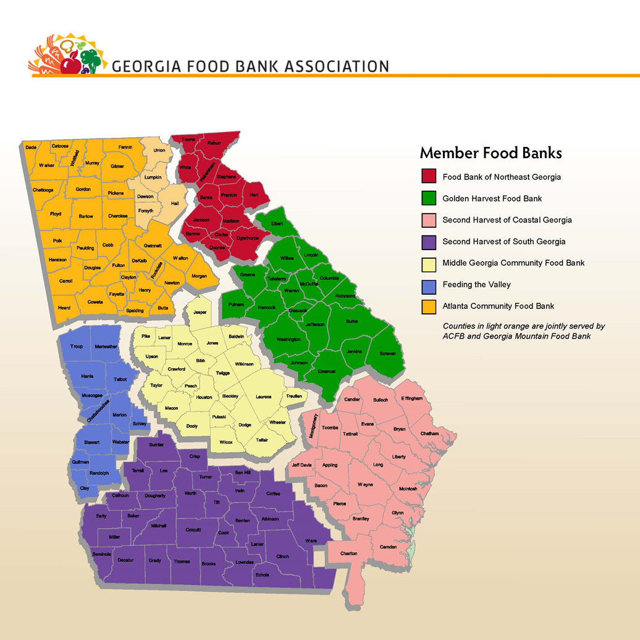

**  
Arby’s Foundation, Georgia Food Bank Association & Georgia 4-H   
Pantry Pride Recipe Contest**

**RECIPE ENTRY FORM**

**NAME COUNTY ___________________________**

**CHECK ONE: ______ 4th, 5th, 6th Grade _ 7th & 8th Grade 9th – 12th Grade**

**AGE: _____ ADDRESS:___________________________ TOWN/CITY________________ ZIP CODE_____________**

**RECIPE CRITERIA: List the items commonly found in Georgia Food Banks that your recipe contains:  
_________________________________________________________________________________________________**

**RECIPE TITLE: _________________________________________________________________________________________________  
  
BRIEF DESCRIPTION OF YOUR RECIPE (explain why is it unique, nutritious, tasty and budget- friendly) _________________________________________________________________________________________________**

**_________________________________________________________________________________________________  
  
_________________________________________________________________________________________________**

**TYPE OF DISH (CHECK ONE):**

**______ No Cook Snack (4th – 6th Grade – Cloverleaf Division)**

**______ Simple Cooked Entrée (7th & 8th Grade – Junior Division)**

**______ Cooked Dish / Entrée ((9th – 12th Grade – Senior Division)**

**YIELD: _______ Servings**

**RECIPE PREPARATION TIME _______________________________________________________________________**

**(Grades 9 – 12 must be prepared in 45 minutes or less from start to finish)**

**RECIPE: (*Ingredients, Measures and Instructions*)**

**Ingredients & Measures:**

**Recipe Instructions:**

**4-H'er Signature _______________________ CEA or 4-H PA Signature __________________________________**



**Arby’s Foundation, Georgia Food Bank Association & Georgia 4-H   
Pantry Pride Recipe Contest**

**Score Card**

**Name __________________________________________**

**Division: 4th-6th Grade ______ 7th-8th Grade______ 9th – 12th Grade______**

**County _________________________________________**

|  |  |  |  |
| --- | --- | --- | --- |
|  |  | **Point Value** | **Score** |
| A) Use of Food Bank Items in Recipe | - Required number of items used  - Relatively low in fat and calories  - Healthy snack, dish or entrée alternative | 25 points |  |
| B) Appeal | - Appealing in appearance  - Appetizing recipe  - Product displayed/presented invitingly in serving dish or on plate *(this does not require a full table setting)* | 15 points |  |
| **C) Creativity** | **- Creative/innovative recipe**  **- Unique ingredients used**  **- Imaginative idea** | **20 points** |  |
| D) Flavor | - Tasty in flavor  - No ingredients over-bearing in taste - Would appeal to a wide range of families | 15 points |  |
| E) Technique/ Presentation | - 4-H recommended preparation techniques used  - Food Safety observed in preparation - Neatness in preparation is observed and area is left clean when cooking is complete | 10 points |  |
| F.) Budget | -Budget-Friendly Recipe  -Relatively low in cost for number of servings in snack/dish/entrée | 10 points |  |
| G.) Time Limit | -Time limit of 45 minutes is observed | 5 points |  |
| **Total Score** |  | **100 points**  **Total** |  |